 |  | Daily Brief
Thursday December 15, 2005  20051215-0 |  | CEO Roger Snoble
In this issue:
- Media View Massive Tunnel Boring Machines For Eastside Project
- Metro Certifies Expo FEIR/FEIS
- Fatal Accident
- Metro Orange Line Accidents/Photo Enforcement
- California Transportation Commission Approval
- FTA New Starts Projects Quarterly Review Meeting
- New York Times to Highlight Metro's Art and Design Efforts

Media View Massive Tunnel Boring Machines For Eastside Project

Numerous media outlets attended this morning’s press event where massive tunnel boring machines were lowered into the ground for the Eastside Extension of the Metro Gold Line. Construction crews lowered segments of two tunneling boring machines into a future Metro Rail station box at Mariachi Plaza. Mayor Villaraigosa, Supervisor Gloria Molina, LA City Councilman Jose Huizar, Doug Failing of Caltrans and other community members joined me in providing the media a first-hand look at construction work taking place along the alignment. Media Relations also issued a news release announcing the insertion of the twin boring machines. Positive news stories are expected throughout the day, evening and tomorrow.

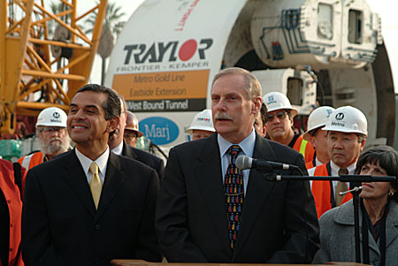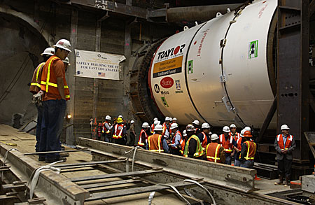

Metro Certifies Expo FEIR/FEIS

Media Relations issued a news release today announcing Board action in certifying the Los Angeles Mid-City/Exposition Corridor Final Environmental Impact Statement/Report paving the way for the start of construction on the project. Stories are expected tomorrow in the Daily News and Los Angeles Times.

Fatal Accident

Media Relations responded to the scene of a fatal accident early this morning involving a car traveling at high speed along La Cienega Boulevard near Sawyer Street. The speeding car sheared off a fire hydrant and hit several trees and newspaper stands before striking the back end of a parked Metro Bus. No passengers were on board the bus at the time of the accident and the bus operator was not injured. The accident drew scores of media this morning. LAPD confirmed two individuals in the car, believed to be former NFL players, died at nearby hospitals as a result of their injuries. Media stories on the accident are expected throughout the day and evening.

Metro Orange Line Accidents/Photo Enforcement

The Los Angeles Times has inquired about the number of accidents on the Metro Orange Line. Staff reported that there have been eight accidents on the line since it opened October 29. In addition to the eight accidents, one other accident was recorded by Metro, which occurred before the line opened on October 27. The LAPD has reported six accidents since they only record injury-based accidents. All accidents are reported to be a result of red light violations. KFI and KFWB radio news reporters interviewed Media Relations staff for an update on photo surveillance cameras that will be installed early next year on the Metro Orange Line to thwart motorists from running red lights.

California Transportation Commission Approval

Today the California Transportation Commission (CTC) approved several requests from Metro:

1. Approved the Final Environmental Impact Report (FEIR) for Traffic Congestion Relief Program (TCRP) Project # 37.2/Mid-City/Exposition Light Rail Transit, so as to allow future consideration of state funding. This is an important approval because Metro already has requested a TCRP allocation of $208.1 million for project construction and a reimbursement of $14 million on a TCRP Letter of No Prejudice (LONP) for preliminary engineering activities for the project at the CTC's February 2006 meeting.

2. Approved a $3,772,000 allocation request to fund FY 05-06 State Transportation Improvement Program eligible activities related to Metro planning, programming and monitoring activities (project development and delivery).

3. Approved two AB 1335 Letters of No Prejudice for local funds to be expended in anticipation of future reimbursement for the following GARVEE bond-funded, TCRP projects that are underway:
- TCRP Project #51 - Route 101/405 Auxiliary Lane Project, which is currently budgeted at $45.7 million and is scheduled to be opened to the public in April 2007. LONP authorization of $1,790,000 approved.
- TCRP Project #52 - Route 405 HOV Lanes from Waterford to I-10, which is currently budgeted at $50.0 million and is scheduled to be opened to the public in March 2007. LONP authorization of $9,648,000 approved."

FTA New Starts Projects Quarterly Review Meeting

The next FTA New Starts Projects Quarterly Review Meeting is scheduled for Wednesday December 21 at 10am here at the Gateway building. These quarterly meetings serve to review Metro's federally funded construction projects. These projects include the Metro Gold Line Eastside Extension, the 2550 Vehicle Program and the Mid-City/Exposition LRT Project. The FTA is also interested in Metro's BRT projects and requests a briefing on the Metro Orange Line. Other quarterly updates include status of legal issues, the Consent Decree, and safety and security matters. The CEO's office provides an update on current Metro issues including significant changes to the organization, budget and finance issues, labor negotiations, ridership and Metro Operations status.

New York Times to Highlight Metro's Art and Design Efforts

The New York Times interviewed Maya Emsden, DEO of Creative Services, regarding Metro's recent bus related art and design initiatives. West Coast architecture and design writer Frances Anderton (who also produces Warren Olney's "Which Way LA" and "To the Point" on KCRW), was taken by innovative bus seat fabric (designed by local artist Pae White), bold bus fleet exterior designs (Local, Rapid, Liner, Express) and the articulated bus design. An article with photos is expected to run in the New York Times "Currents: Los Angeles" section later this week or next.

Metro.net Home | Press Room | Projects & Programs | Meeting Agendas | Riding Metro | Metro Library

Los Angeles County Metropolitan Transportation Authority
1 Gateway Plaza
Los Angeles, California 90012-2952
Phone: 213-922-6888
Fax: 213-922-7447

