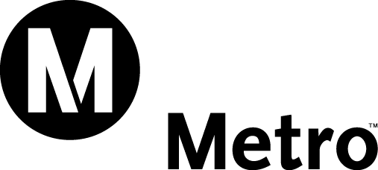 |  | Daily Brief
Tuesday, April 08, 2008  20080408-0 |  | CEO Roger Snoble
In this issue:

- USDOT to Develop Next Steps on Congestion Reduction Demonstration Initiative
- Media Inquiry into New York’s Refusal to Act on Congestion Pricing Proposal
- LA City Council Approves South Park Wetlands & Division 2 Billboard Permit
- Metro Gold Line Eastside Extension Promotion

USDOT to Develop Next Steps on Congestion Reduction Demonstration Initiative

In the aftermath of New York City’s failed congestion pricing proposal and the loss of its $354 million federal urban partnership grant, we have actively engaged in dialogue with US Department of Transportation (USDOT) officials to determine next steps. Assistant Secretary Tyler Duvall, the Administration’s lead official on congestion pricing, informed us today that USDOT staff is currently in the process of developing a proposal for Secretary Peters on how to proceed with the congestion reduction program. Mr. Duvall was not at liberty to disclose how the Administration intends to allocate the grant money, nor did he specify a particular timeframe for final decisions. He added that the Department continues to have significant interest in demonstrating the benefits of congestion pricing in the most heavily congested metropolitan area in the nation. I will keep you informed as more information becomes available.

Media Inquiry into New York’s Refusal to Act on Congestion Pricing Proposal

Today, the New York Daily News contacted us for a reaction to New York’s decision to turn down the USDOT grant on congestion pricing. Media Relation staff told the reporter that the Los Angeles area is one of 35 urban areas seeking funding for a congestion reduction demonstration project. To the extent that the New York City grant becomes available to other areas, it would add more money for such projects. The reporter was told that we will have to wait and see what USDOT does at this point. Stories ran today in the Los Angeles Times and the News York Times. Additional stories are expected to run tomorrow.

LA City Council Approves South Park Wetlands & Division 2 Billboard Permit

Today, the Los Angeles City Council approved recommendations that would allow for the development of a nine-acre wetlands park at our current South Park facility. In addition, it would also establish a Sign Supplemental Use District (SSUD) to permit the erection of two billboards on our Division 2 bus facility property at San Pedro and 16th Streets.

With this approval, we would agree to sell the South Park property to the City of LA in return for the City allowing Clear Channel Outdoor (CCO) to use the two billboards, which would settle CCO's lawsuit against us seeking damages for the removal of 14 billboards in the median of Santa Monica Boulevard in West Los Angeles. The SSUD item, which involves passage of an ordinance, was approved 13 to one. Since the ordinance vote was not unanimous, a second Council vote will take place next week and only a simple majority (eight votes) will be required for passage.

Metro Gold Line Eastside Extension Promotion

Three and half years ago, Metro declared “Next stop: ELA. The Metro Gold Line Eastside Extension is priority one.” Today the project is 78% complete and continues to have a phenomenal safety record.

To generate excitement about the imminent opening, Regional Community Relations has implemented a banner campaign that communicates “Metro is building opportunities to…” Community Relations has solicited and confirmed participation of over 30 stakeholders along the alignment from the Little Tokyo/Arts District to East Los Angeles.

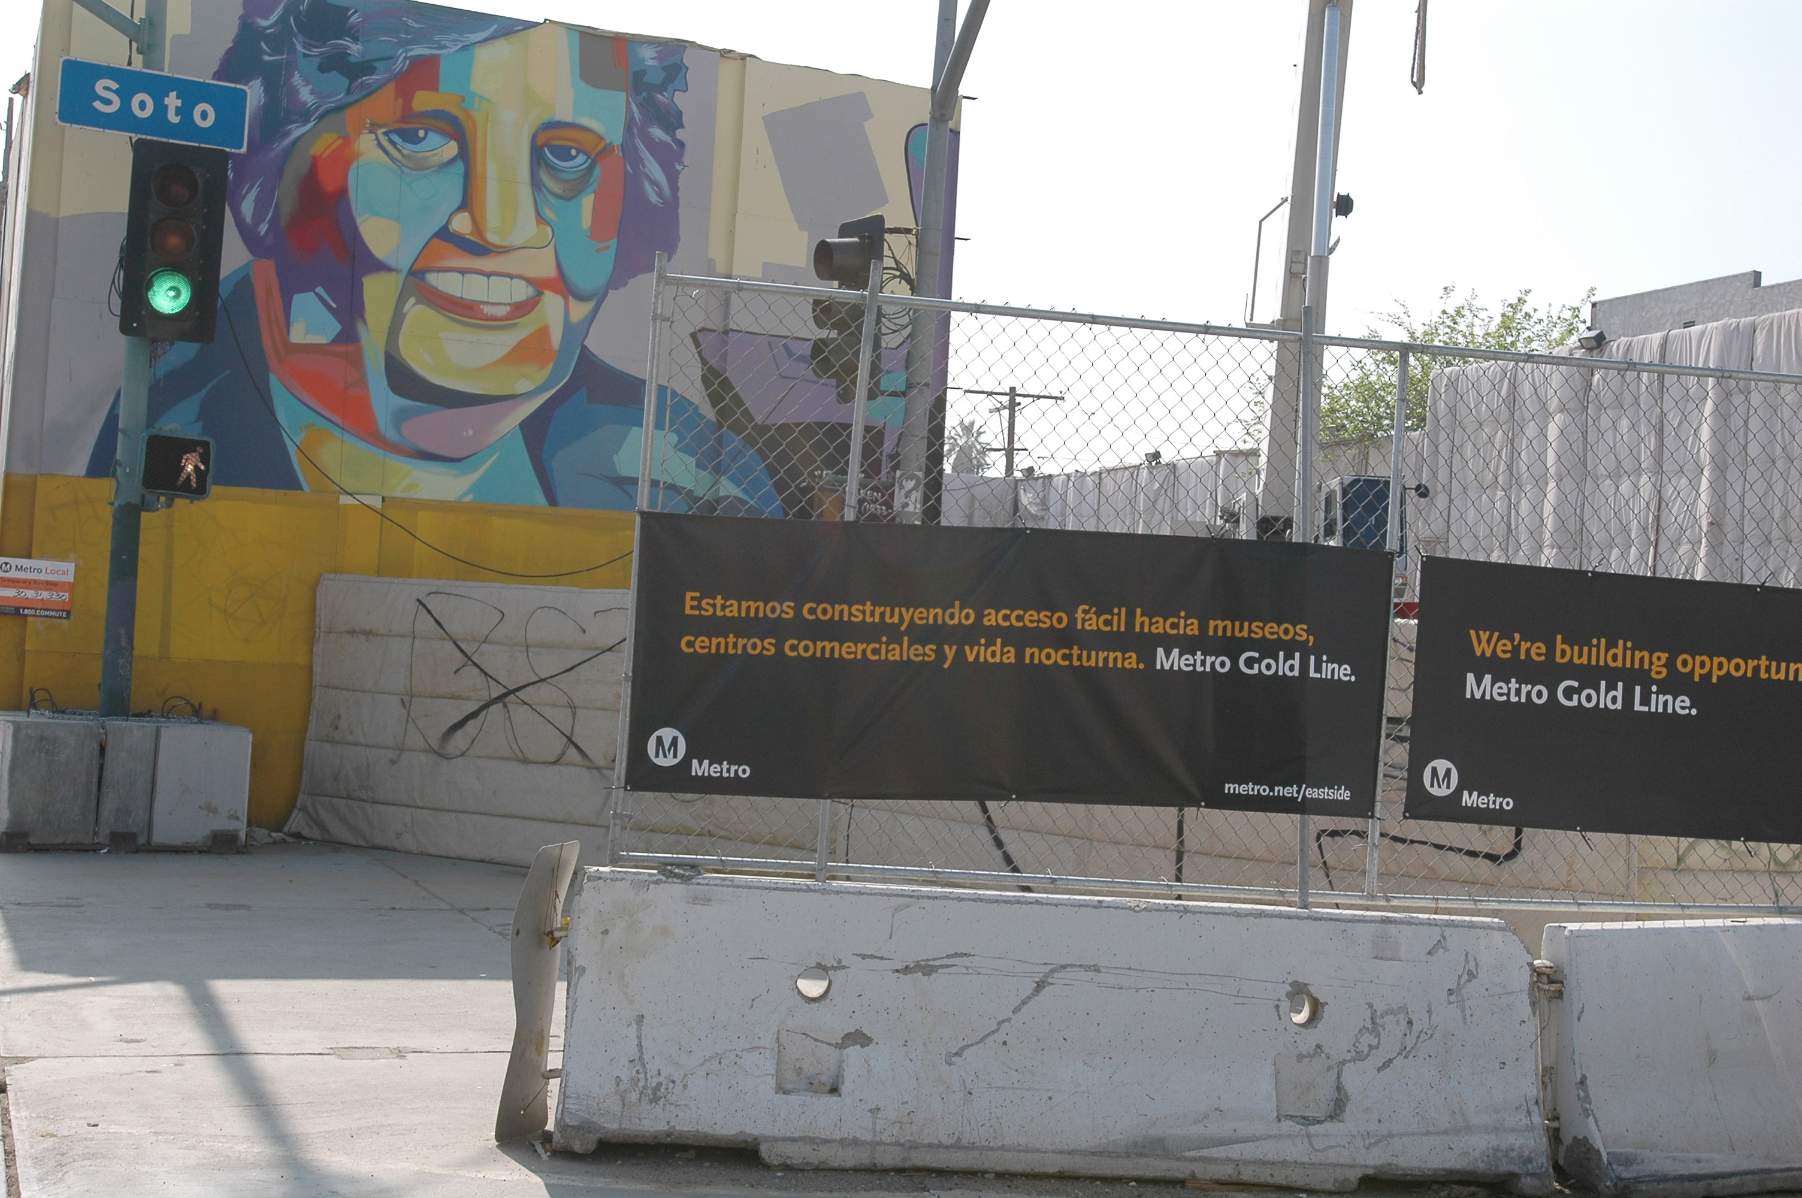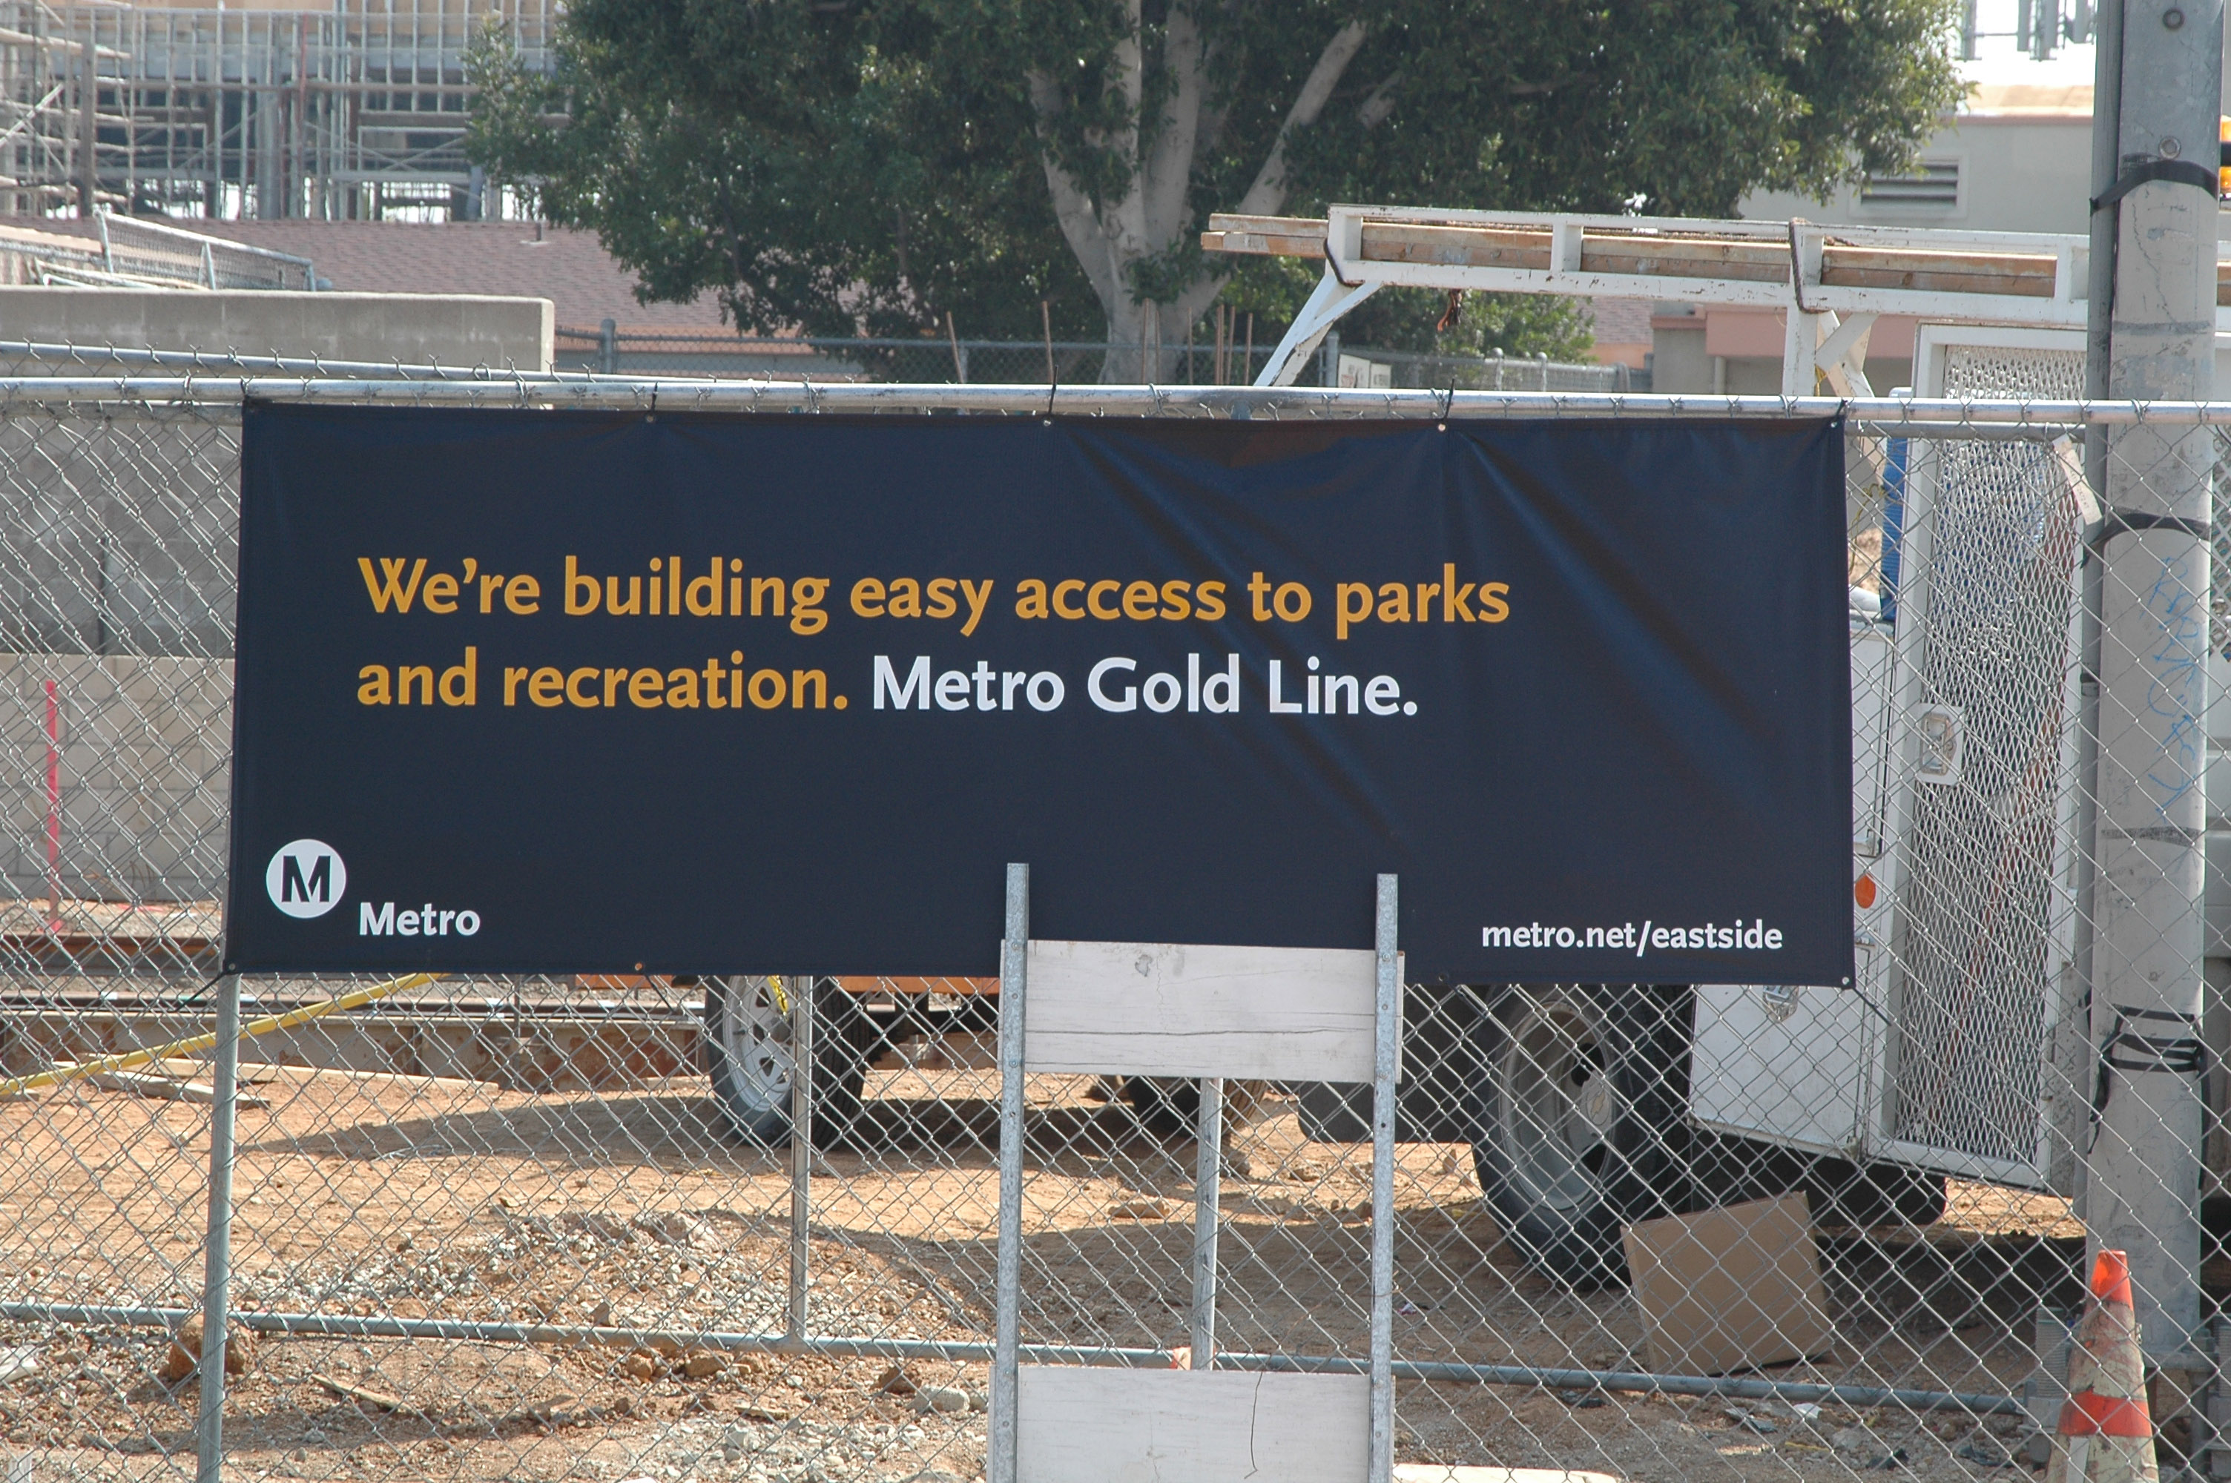

Metro.net Home | Press Room | Projects & Programs | Meeting Agendas | Riding Metro | Metro Library

Los Angeles County Metropolitan Transportation Authority
1 Gateway Plaza
Los Angeles, California 90012-2952
Phone: 213-922-6888
Fax: 213-922-7447

