Metro Rapid Expansion Program

Background


Los Angeles County Metropolitan Transportation Authority (MTA) developed a conceptual plan for expanding the successful Metro Rapid Demonstration Program as part of the most recent Long Range Transportation Plan. The conceptual plan included 22 expansion lines and was based on a limited selection process. The process included only MTA lines and was confined to those lines with more than 10,000 weekday unlinked boardings.

The MTA Board of Directors approved work to expand the Demonstration Program (Phase I) in May 2001, based on the plan identified in the Long Range Transportation Plan (LRTP). This direction called for three principal work efforts:

- Reconfirm the lines identified in the LRTP through more extensive analysis and the consideration of additional MTA and Municipal lines, and prioritize potential Metro Rapid candidate lines into an updated phased implementation plan
- Implement an initial expansion phase of 6-7 lines
- Monitor, analyze, and improve Metro Rapid operations, facilities, and customer experience

This report presents the first element in this work: selection of the Metro Rapid Expansion Program lines (Phase II).

Selection Process

The selection process involved three principal steps:

- Identify potential candidate lines for Metro Rapid service
- Refine and evaluate candidate lines
- Recommend candidate lines on a priority basis

Identify Potential Candidate Lines

The LRTP Metro Rapid conceptual plan evaluated all MTA lines with over 10,000 weekday boardings based on the idea that a critical threshold of ridership would be required to justify and support both Metro Rapid
and local service on a given corridor. This resulted in a short list of 41 corridors and was considered sufficient at that time. Since then there has been a desire on the part of both MTA and Municipal Operators to consider “Muni” corridors as possible Metro Rapid candidates based on the premise that certain corridors had the necessary characteristics to support Metro Rapid service and provided necessary network linkages.

Initially, a lower ridership level of 5,000 weekday unlinked passenger boardings was considered the threshold for Metro Rapid consideration, recognizing that most Muni lines were shorter than MTA lines. However, working sessions with MTA Planning and Operations staff suggested using a new threshold based on unlinked weekday passenger boardings per mile of route in order to factor out the effect of the overall route length. The candidate selection was modified to reflect this approach.

Minimum thresholds for Phase II were established at 500 weekday passenger boardings per mile of route with a minimum route length of 10 miles in order to ensure that the necessary ridership levels and opportunities for significant travel time savings were met. A secondary consideration was given to routes with boardings per route mile of 400 to 500 for possible inclusion. Forty-one candidate lines were selected for evaluation as noted in Exhibit 1.

Refine and Evaluate Candidate Lines

Key criteria were identified as influencing the success of Metro Rapid and, in fact, any major transit investment. These criteria are:

- Corridor Transit Potential – measures transit potential by a composite index of residential and employment density within walking distance of the possible Metro Rapid alignment.

- Corridor Transit Dependency – measures transit dependency by a composite index of percentage of households below poverty and percentage of households without vehicles.

- Current Transit Service – measures transit utilization through a variety of service and ridership variables, including weekday ridership, percent of weekday ridership retained on weekends, weekday passengers per mile of route, weekday passengers per revenue hour, weekday seat utilization, average passenger trip length, and revenue operating speed.
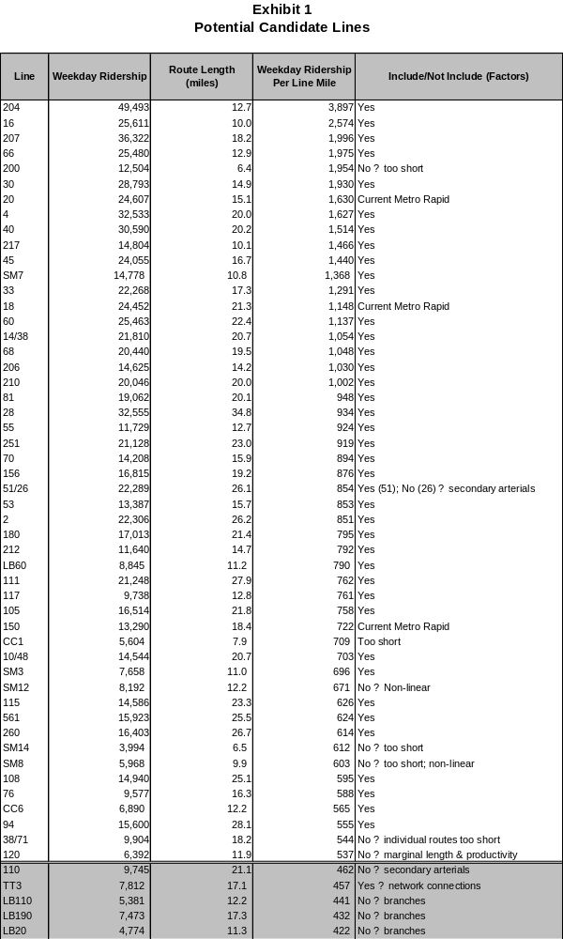
The evaluation was conducted in two steps using both tabular and geographic information assessment:

- Step I Refinement − evaluated a subset of the above criteria in terms of refining the existing transit route alignments. Many of the current routes contain both segments with strong transit orientation and segments where Metro Rapid is clearly inappropriate. The objective was to identify the core part of the corridor upon which to evaluate Metro Rapid opportunities.

- Step 2 Evaluation − evaluated the refined Metro Rapid candidate corridors using all above criteria.

- Step 3 Service Warrants − considered other important factors in assessing the candidates for Phase II Metro Rapid service. These factors included whether current service frequencies could sustain two types of all day service, the current presence of limited stop or express service, whether it duplicates other Metro Rapid Transit (Metro Rapid or Metro Rail), and lastly whether there are special network issues to consider.

STEP ONE − REFINEMENT

The subset of evaluation criteria included transit potential (population and employment density), transit dependence (households below poverty and without vehicles), and two current transit characteristics (weekday ridership and ridership per mile of route). To assist in identifying corridor strengths by segment, population density, employment density, households below poverty, and households without vehicles were mapped at the census block level within ½ mile of the candidate corridor. In addition, ridership was reviewed at a bus stop level using the latest available ridership information (ridechecks).

The baseline corridor was analyzed and a proposed refined corridor identified for each of the candidate lines. Most were somewhat changed, with a few changing significantly and a few not changing at all. An example of this analysis is presented in Exhibit 2. The complete set of all candidates is available in a separate Technical Appendix.

STEP TWO − EVALUATION

The evaluation consisted of analyzing all criteria in the transit potential, transit dependence, and transit characteristics elements and comparing the refined candidate corridors using a ranked scoring process. This scoring process used a “percentage of the best” approach, whereby the top scoring candidate in each criteria received “100%”, with the other candidates receiving scores relative to the top score. For instance, if the
Exhibit 2
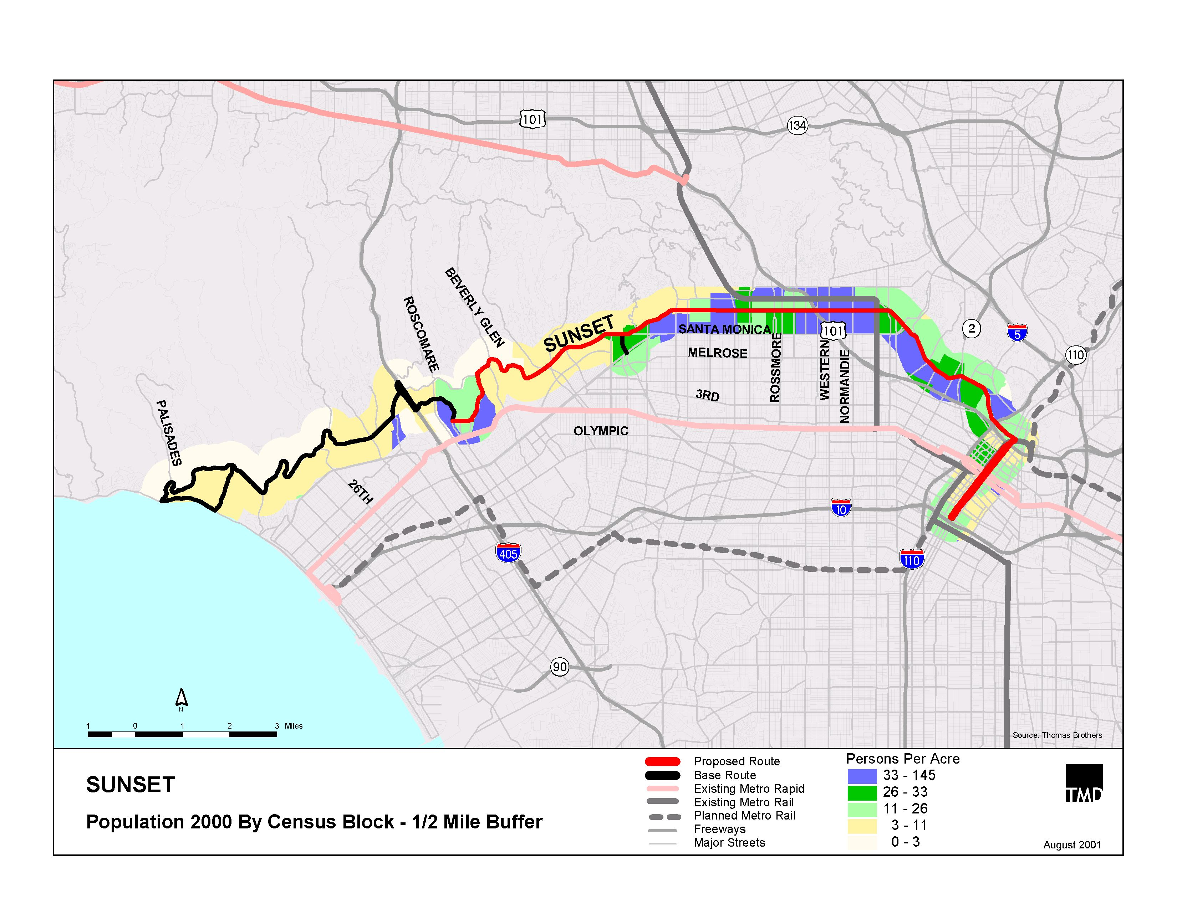
Refinement Example
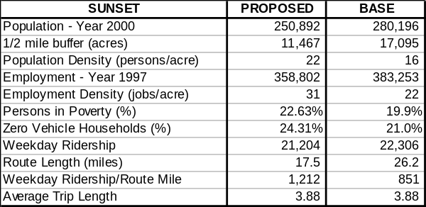

population density was 40 persons per acre (100%), then a candidate with a population density of 30 would receive a score of 75%. Each candidate line received a score for each criteria. An overall score was determined by averaging the individual criteria scores. Transit potential and transit dependency carried a weight of one with transit service carrying a weight of two to allow existing transit success to carry equal weight with the collective transit potential and dependency. The results are presented in Exhibits 3 through 7.

STEP THREE − SERVICE WARRANTS

Service warrants addressed non-quantitative factors that would likely influence the success of the Metro Rapid Expansion Program. These issues included whether current service frequencies could sustain two types of all day service, the current presence of limited stop or express service, whether the service unproductively competes with other Metro Rapid Transit (Metro Rapid or Metro Rail), and whether there are special network issues to consider. Exhibit 8 presents the service warrant findings for the Metro Rapid Phase II candidates.

EVALUATION SUMMARY AND CANDIDATE RANKING
The overall ranked scoring and service warrants for the candidate corridors are presented in Exhibit 9.
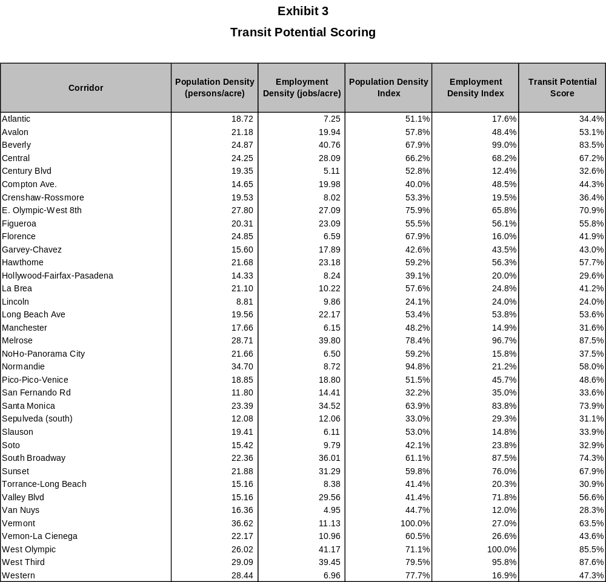

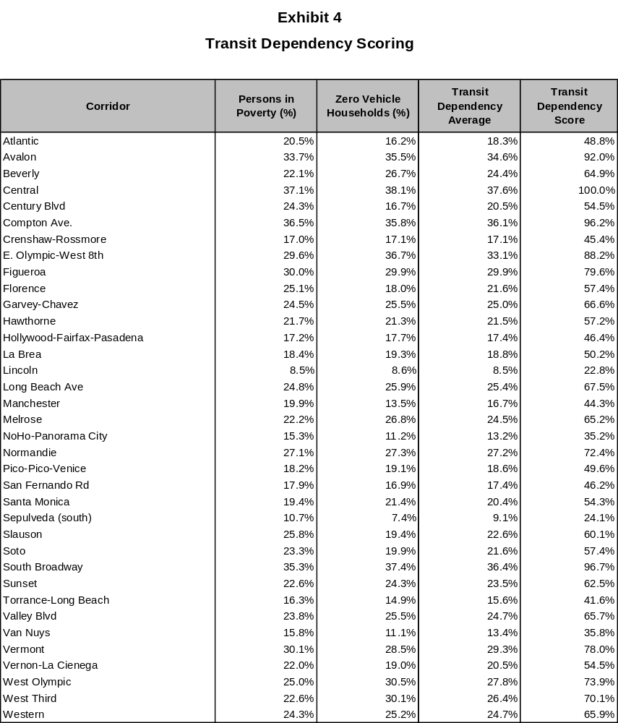

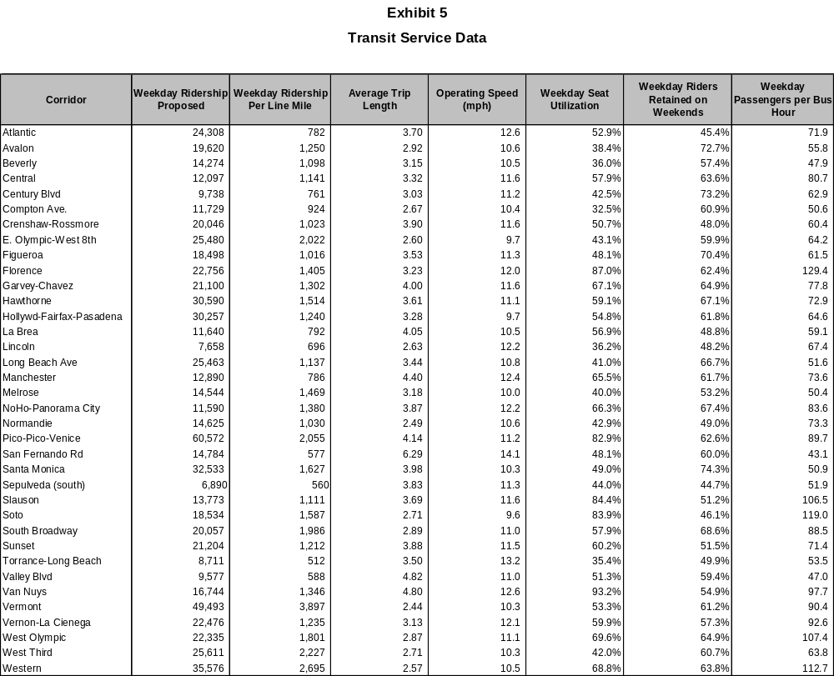
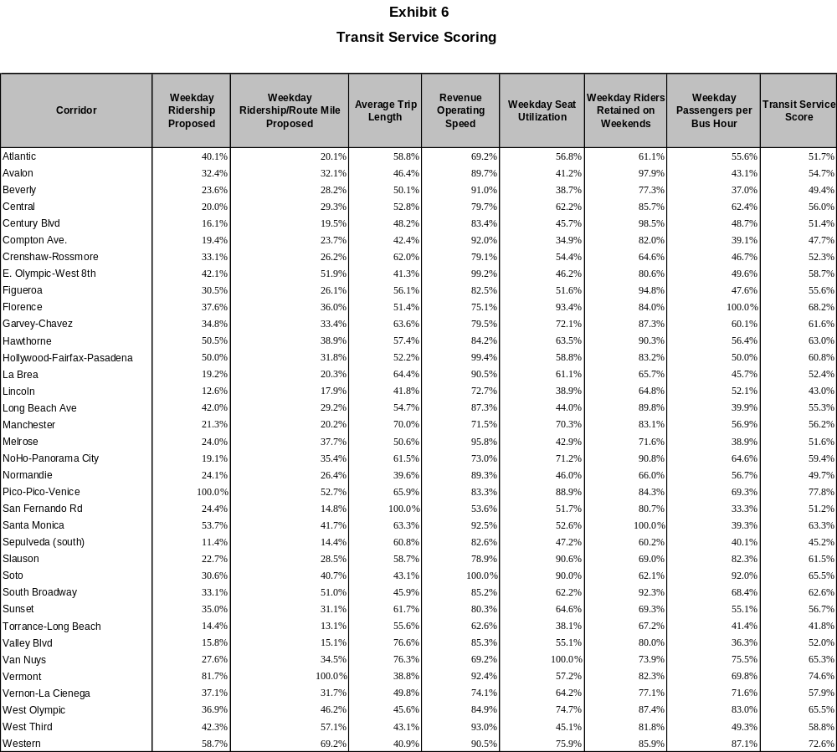
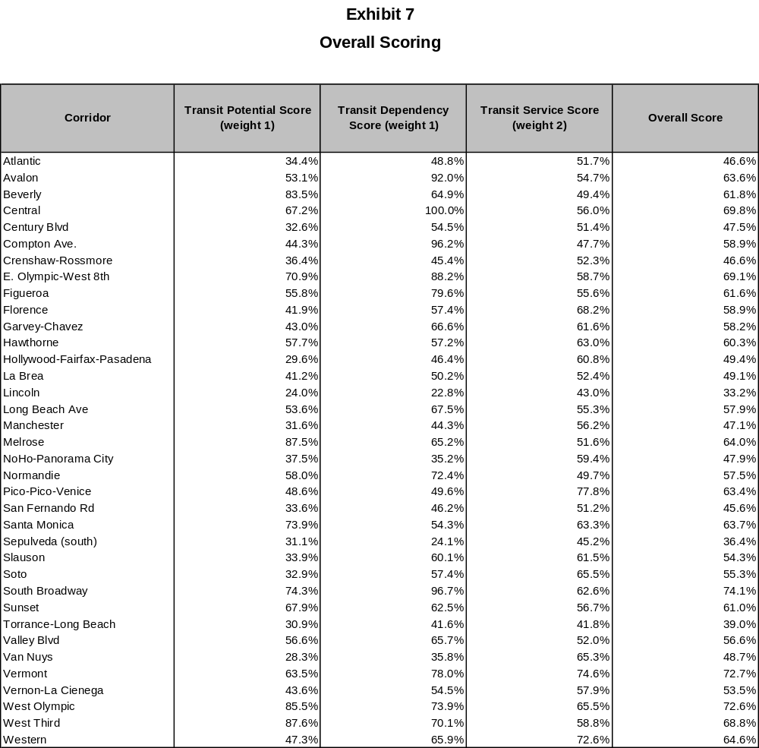

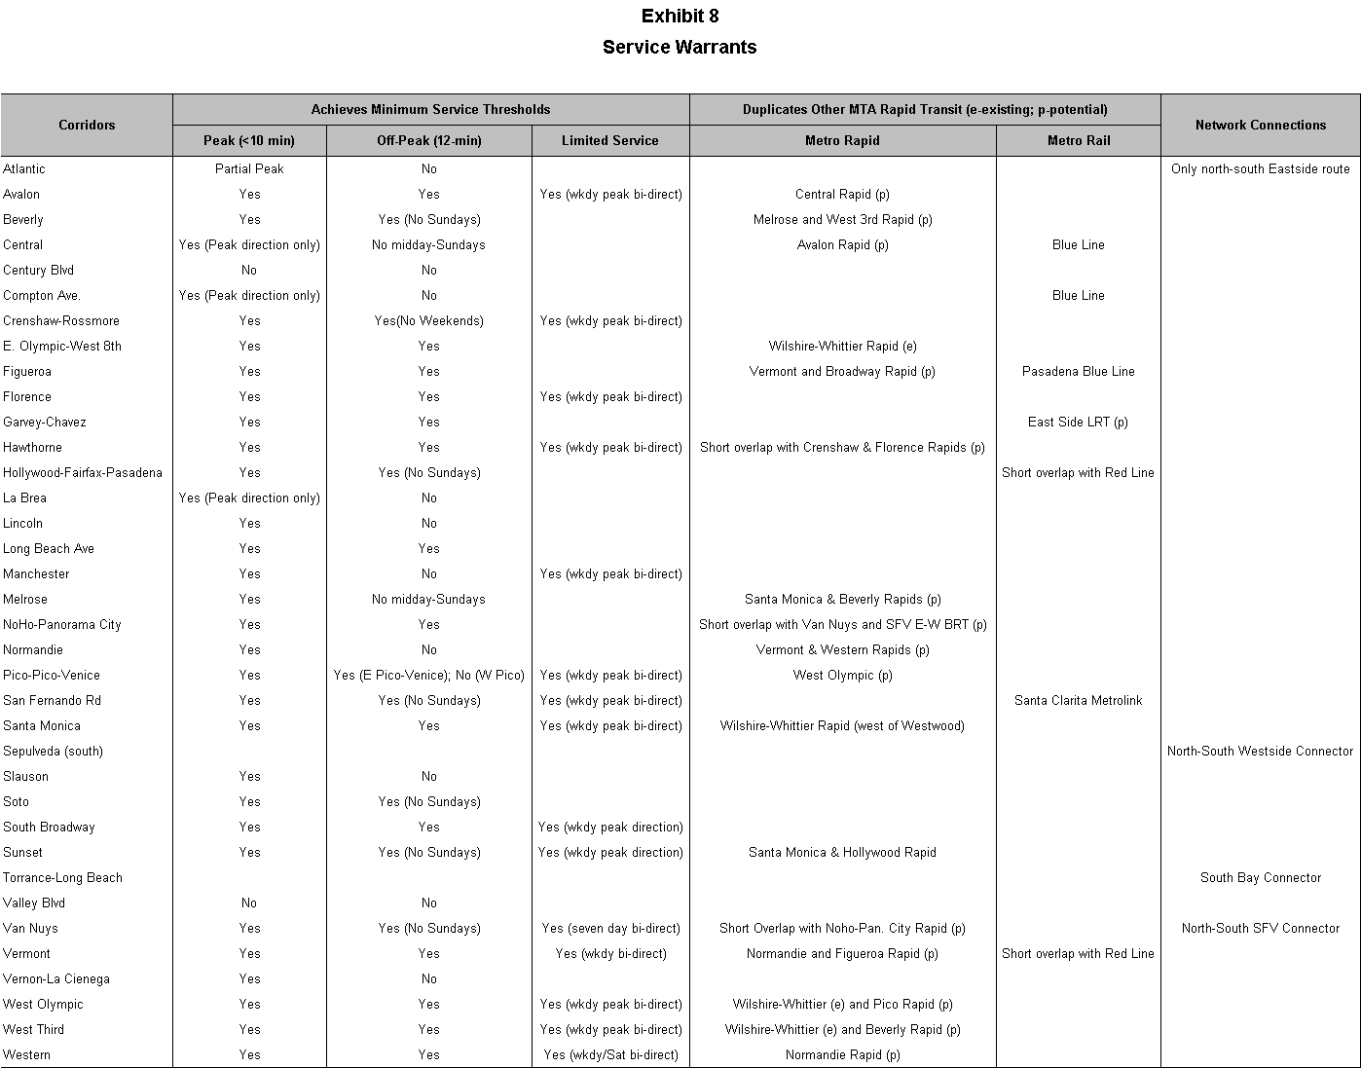
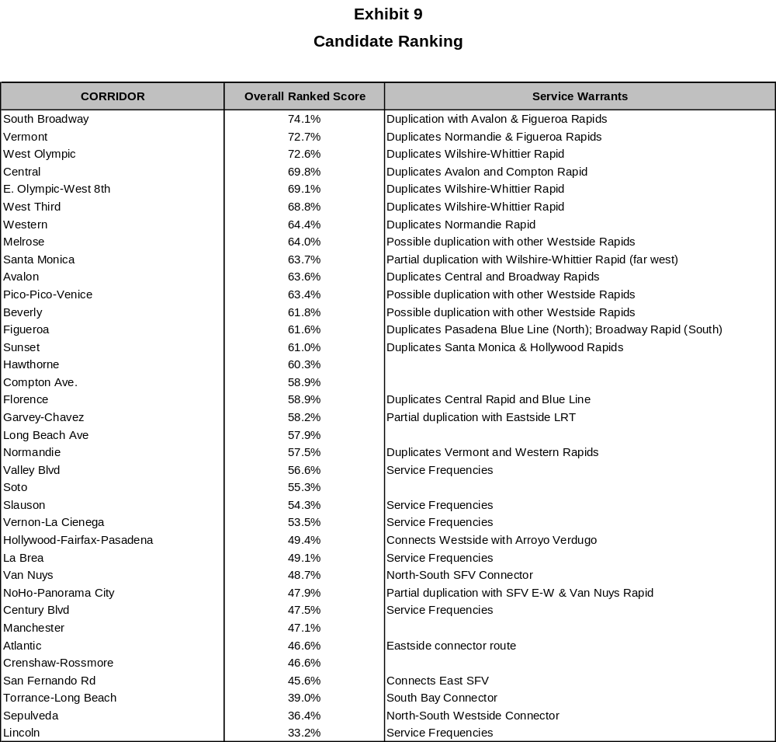

Proposed Metro Rapid Expansion Program

The evaluation process resulted in corridors scored on the basis of existing success (transit service score), potential success (transit potential), and the need for transit (transit dependence). The challenge in selecting corridors is to balance the individual corridor scoring with the needs of the network in terms of connectivity and achieving geographic coverage. Specifically, duplication and competition for the same markets were avoided, as was over saturating one part of a service area.

The Metro Rapid Expansion Program has been prioritized into four sub-phases. It is anticipated that each sub-phase represents a three-year implementation plan of 5-6 Metro Rapid lines. Exhibit 10 presents the phased implementation plan of the Metro Rapid Expansion Program.

Metro Rapid line descriptions have been prepared by phase.

PHASE IIA − 6 Lines

- South Broadway − operates from the Green Line to Gateway Center via the current alignment. One option for consideration is to connect this line with the North Broadway line through Lincoln Heights and El Sereno.

- Vermont − follows the current alignment; some concern has been expressed over the overlap with the Metro Red Line; however, it is believed that these are separate markets and the results will be similar to the Wilshire-Whittier line with both Metro Rapid and Metro Rail benefiting from the new service.

- Pico-Pico-Venice − the only Metro Rapid with branches; the line initiates at Gateway and operates via downtown LA to Pico Boulevard, continuing west to Rimpau where the line splits into two branches (the frequency needed on the trunk is significantly higher than that needed on the outer parts); one branch continues west via Pico to Santa Monica with the other operating via Venice also to Santa Monica. This line will present opportunities to possibly involve Big Blue Bus in Metro Rapid operations.

- Soto − only the branch serving LACUSC Medical Center, Figueroa, and the Pasadena Blue Line is proposed with the south terminal in the vicinity of Firestone in order to maintain arterial access.

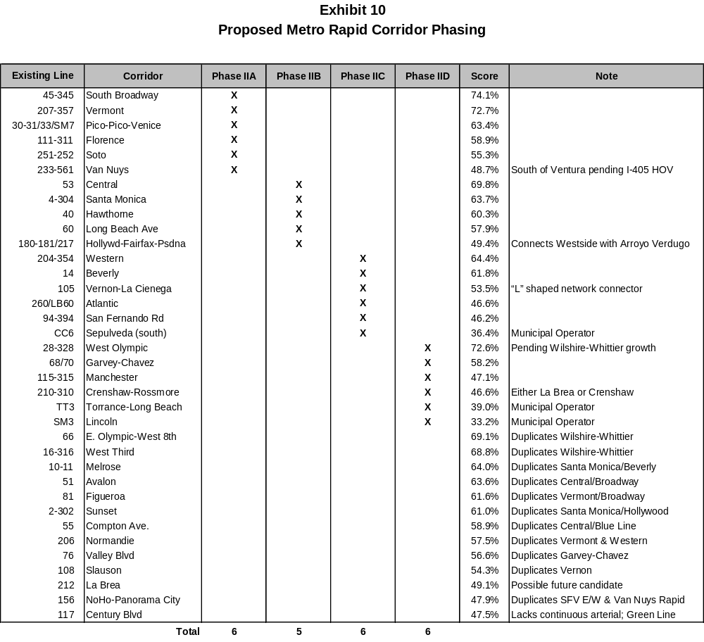
- Florence − operates from an east terminal near Garfield via the current alignment west to Hawthorne, then following a revised alignment on Century to the LAX terminal.

- Van Nuys − serves the full Van Nuys corridor to Lake View Terrace, rather than to the Sylmar/San Fernando Metrolink Station; service needs to continue through the Sepulveda Pass to Westwood, but needs priority measures on I-405 to be effective.

PHASE IIB − 5 Lines

- Central − current alignment south to Blue/Green Line station.

- Santa Monica − follows the current alignment to Santa Monica from downtown Los Angeles.

- Hawthorne − follows the current alignment.

- Long Beach − follows the current alignment to Long Beach from downtown Los Angeles.

- Hollywood-Fairfax-Pasadena − represents the joining of the Fairfax-Hollywood line with the Hollywood-Glendale-Pasadena service. Operates via the current alignment from West LA Transit Center to Glendale then via Colorado to Pasadena City College.

PHASE IIC − 6 Lines

- Western − current alignment south to Blue/Green Line station.

- Beverly − follows current alignment from downtown Los Angeles to a new terminal at Century City; possibly replacing Line 316.

- Vernon-La Cienega − operates via the current alignment with a new east terminal south on Pacific to Florence.

- Atlantic − generally the current alignment with an extension south to downtown Long Beach (the old 260) with Long Beach Transit still operating local services; from Huntington north via Fremont north to Washington.

- San Fernando − follows current alignment except that north terminal is at Sylmar/SF Metrolink Station, no deviation for BGP Airport, and deviation via Glendale CBD.

- Sepulveda − follows the current alignment with a north terminal located closely to the future Westwood Transit Center (Gayley/Wilshire) and to a south terminal at the Aviation Way Green Line Station.

PHASE IID − 6 Lines

- West Olympic − possible line if needed from downtown Los Angeles to Century City via current Line 28/328.

- Garvey-Chavez − operates from downtown Los Angeles via current Line 68 to Atlantic, then continues on regular Garvey route to El Monte.

- Manchester − current east terminal to new west terminal around Sepulveda; no deviations.

- Crenshaw-Rossmore − via the current routing (no Western Station deviation).

- Torrance-Long Beach − follows current alignment from Long Beach to north on Main Street to Carson to Torrance, then continues north on Hawthorne to South Bay Galleria.

- Lincoln − follows current alignment between Aviation Green Line Station to downtown Santa Monica.

Next Steps

The next steps will focus on continuing the refinement process and developing an implementation plan for Phase IIA.

The service protocol for arterial Metro Rapid operation includes both Metro Rapid and local bus service.

