OPERATIONS COMMITTEE

MAY 15, 2002

SUBJECT: SAFETY’S FIRST PROGRAM AND WORKERS’ COMPENSATION STATUS

ACTION: RECEIVE AND FILE

RECOMMENDATION

Receive and file the Safety’s First program and workers’ compensation status report for the period covering January 2002 through March 2002.

DISCUSSION

Background

The Board receives an ongoing quarterly update on the status of workers’ compensation, expanded in February 2002 to include the status of the agency’s new Safety’s First program. The workers’ compensation claims detail for the third quarter of FY 2002 is included in Attachment A.

Per the Operations Committee’s direction in February, the current report also includes an update on the activities and accomplishments of the Special Investigations Unit and a discussion of the impacts of State Assembly Bill 749.

Status Report & Accomplishments

Safety’s First Program

- Adopted the five-year Strategic Safety Management Plan and departmental Safety Action Plans (SAPs). The SAPs include specific safety performance measures by quarter and responsible individuals in each department or division.

- Initiated Local Safety Committees at each operating location. Local Safety Committees are being formed in partnership with the unions and will have the responsibility of reviewing local accidents, injuries and accident investigation processes; identifying hazards and unsafe practices; and implementing programs or new safety practices to reduce injuries, accidents and lost days.

- Continued the work of the Safety Steering Committee and the Gateway and Operations Tactical Committees. Met monthly with the Safety Oversight Committee to brief labor management on the safety program and to encourage their participation.

- Continued two-day safety skill building seminars for managers and supervisors. Over 650 staff have received the training to date. A new series of sessions for all line employees is being planned for roll out in June/July, continuing until all employees are trained.

- Incorporated safety into the performance based compensation instrument and performance factor descriptions. This instrument will be used for employee evaluations starting in FY03.

- Updated and improved the safety scorecard that will be used to evaluate the program’s effectiveness on a monthly basis (Attachment B).

- Continued safety program kick-offs at all MTA divisions and locations, to be completed by mid-April.

Workers’ Compensation/Claims Management

- Fully implemented the Special Investigations Unit (SIU). The new SIU consists of a manager, two in-house investigators and a panel of private contract firms that will be utilized to conduct sub rosa investigations for the MTA. The panel will also provide the compensability investigations for the Claims Administration Unit. See Attachment C for further detail on the SIU’s activities.

- Established a partnership with District Attorney’s Fraud Investigation Unit and began planning a pilot program aimed at prevention of fraud.

- Hired the Injured Workers’ Advocate.

Impacts of AB749

AB749, signed by the Governor, increases workers' compensation benefits and implements cost-saving reforms in the administration of the workers' compensation system starting on January 1, 2003. The legislation introduces the following workers’ compensation benefit enhancements:

- The temporary disability benefit maximum (66.7% of pay) will increase from the current $490 weekly to $602 weekly for 2003. Most MTA employees will be eligible to receive the maximum benefit.

- The minimum permanent partial disability benefit has been raised from $70 to $100

The estimated FY03 workers’ compensation expense, excluding the AB749 benefit increases but including cost reduction targets, is $45.0M. The benefit improvements will add approximately $4.6M, for a total of $49.6M.

AB749 does include cost mitigation factors that have been omitted from this analysis because of the difficulties in estimation. These cost mitigation measures are as follows:

- Eliminates the treating physician presumption of correctness except where the physician is predesignated
- Authorizes the creation of an outpatient fee schedule
- Establishes pharmacy cost controls
- Doubles fraud penalties
- Allows employers access to medical information in regard to the condition being claimed as industrial

NEXT STEPS

The MTA/Dupont team will continue implementation of the Safety Program. Tasks scheduled for the fourth quarter include the following:

Complete all supervisor and manager safety skills building sessions; begin line employee level safety skills training
- Complete design/begin implementation of the fraud prevention pilot program

Monitor implementation of the Safety Action Plans
- Incorporate safety into job descriptions for all newly posted positions

Update the safety scorecard monthly
- Conduct monthly meetings of the Safety Program committees
- Continue roll out of the safety communications plan

ATTACHMENTS

- Claims Report
- Safety’s First Scorecard
- Special Investigations Unit (SIU) Update on Activities

Prepared by: Andrea Burnside, Operations Executive Administration Mgr.

John B. Catoe, Jr.
Deputy Chief Executive Officer
Roger Snoble
Chief Executive Officer

ATTACHMENT A

Claims Report

Average monthly new claims (222) were lower than both the average for the previous quarter (226) and the same period last year (258).

During the first nine months of fiscal year 2002, there were a total of 84,299 lost workdays due to on-the-job injuries, 1.5% higher than the same period last year (83,029).

The inventory of pre-Travelers self-insured claims decreased from 1,726 to 1,599, a decrease of 7.4%. Staff continues to monitor Travelers’ handling of these claims to ensure cost effective and appropriate settlements.

Employees Out on WC
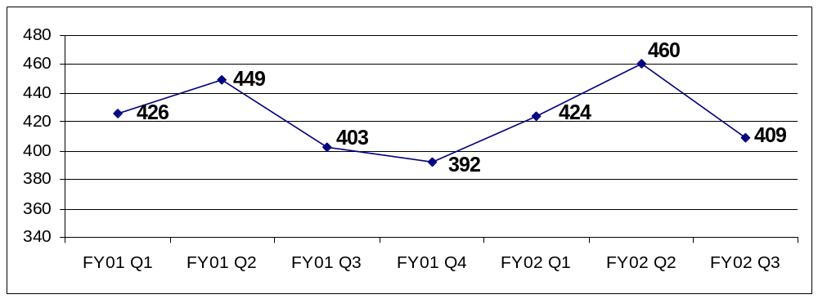
Lost Workdays Due to Occupational Injuries
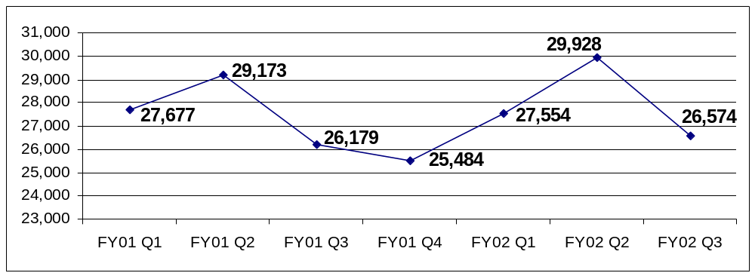

ATTACHMENT B

Accident and Injury Scorecard Report

New Lost Work Time Claims Reported per 100 Employees

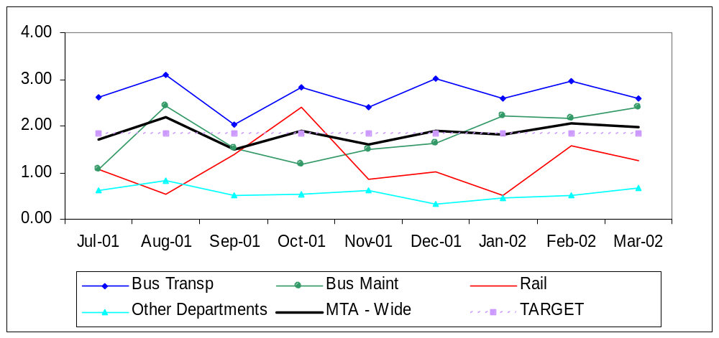
*Bus Maintenance Division data includes Facilities Maintenance and Regional Rebuild Center.

 | Jul-01 | Aug-01 | Sep-01 | Oct-01 | Nov-01 | Dec-01 | Jan-02 | Feb-02 | Mar-02
Bus Trans | 2.62 | 3.08 | 2.03 | 2.83 | 2.39 | 3.02 | 2.59 | 2.95 | 2.59
Bus Maint | 1.08 | 2.44 | 1.51 | 1.18 | 1.48 | 1.64 | 2.20 | 2.15 | 2.40
Rail | 1.06 | 0.53 | 1.39 | 2.39 | 0.85 | 1.02 | 0.51 | 1.58 | 1.24
Other Depart. | 0.61 | 0.82 | 0.50 | 0.53 | 0.61 | 0.33 | 0.45 | 0.49 | 0.66
MTA - Wide | 1.70 | 2.20 | 1.50 | 1.90 | 1.60 | 1.90 | 1.82 | 2.06 | 1.97

Lost Work Time Days per 100 Employees

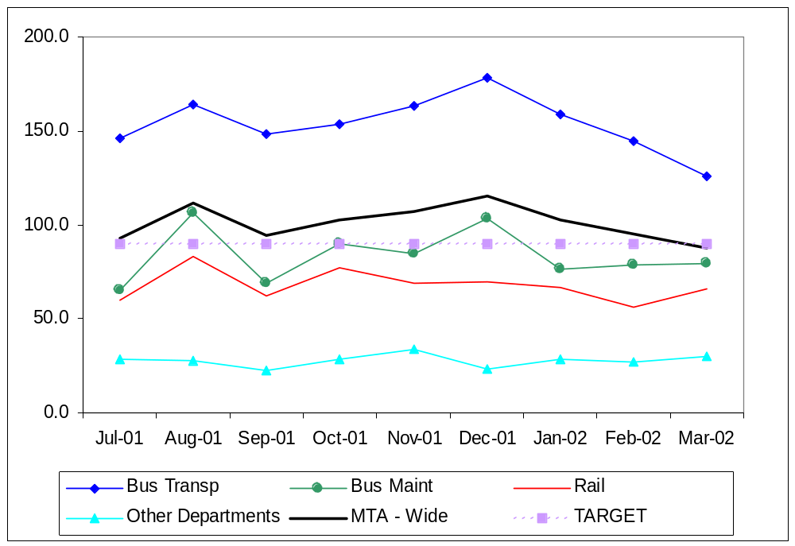
* Bus Maintenance Division data includes Facilities Maintenance and Regional Rebuild Center.

 | Jul-01 | Aug-01 | Sep-01 | Oct-01 | Nov-01 | Dec-01 | Jan-02 | Feb-02 | Mar-02
Bus Trans. | 145.7 | 164.2 | 148.5 | 153.4 | 163.6 | 178.5 | 159.1 | 144.5 | 126.1
Bus Maint | 64.8 | 106.2 | 68.9 | 90.0 | 84.4 | 103.3 | 76.4 | 78.5 | 79.7
Rail | 60.0 | 82.8 | 62.2 | 77.4 | 69.1 | 69.7 | 67.0 | 56.1 | 65.6
Other Depart. | 28.7 | 27.9 | 22.6 | 28.3 | 34.0 | 23.5 | 28.2 | 27.3 | 29.6
MTA – Wide | 93.0 | 111.6 | 94.4 | 102.8 | 107.2 | 115.7 | 102.3 | 95.0 | 87.9

Bus Accidents per 100,000 Hub Miles
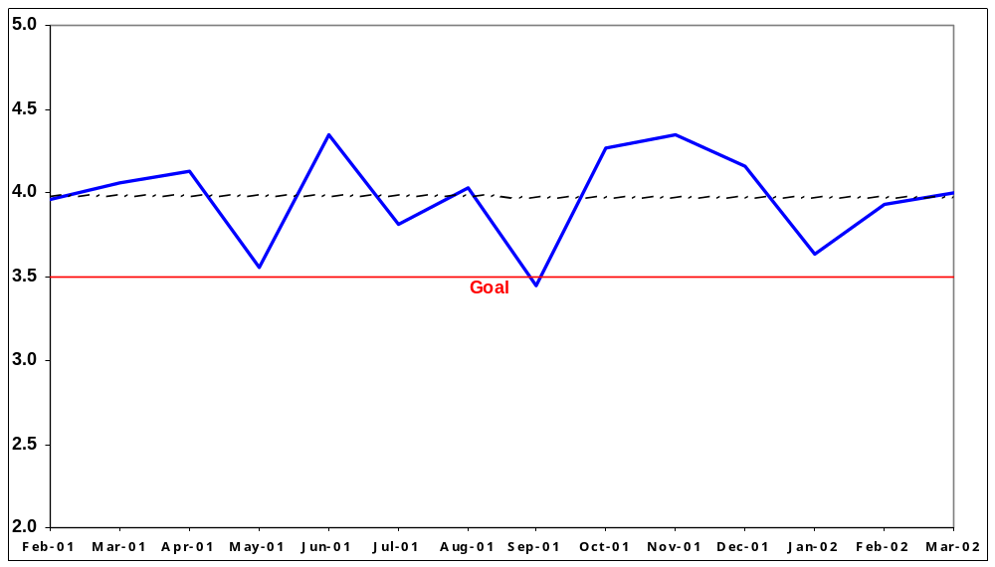

Rail Accidents per 100,000 Train Miles
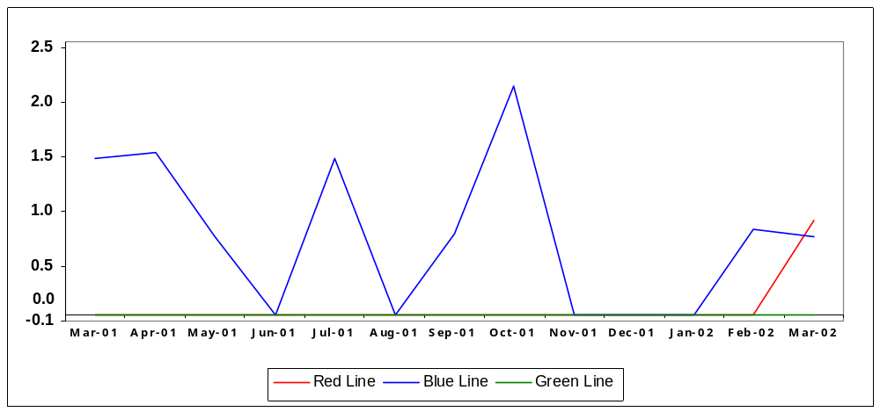
ATTACHMENT C

Special Investigations Unit (SIU)
Update On Activities

January through March 2002 was the first full quarter of operation for MTA’s newly formed Workers’ Compensation Special Investigations Unit (SIU). Prior to January 2002, the SIU was the responsibility of the MTA Contract Claims Administrator/Insurance carrier. A recent reorganization has located the SIU Unit within the new Corporate Safety Department.

The following activities, undertakings and accomplishments occurred in the third quarter of FY 2002, January 1, 2002 through March 2002:

- The draft of the MTA SIU procedures was completed. (Currently under review by County Counsel).

- The Workers’ Compensation Fraud and Abuse Hot Line was installed and is currently operational.

- A draft announcement for the new Hot Line is under review by County Counsel.

- The SIU participated in meetings with County Counsel, the Los Angeles District Attorney’s Workers’ Compensation Fraud Unit, and the California Department of Insurance, Workers’ Compensation Fraud Unit. The goal of these meetings is to develop a memorandum of understanding (MOU) between the Agencies designed to effectively tackle the overall goal of decreasing workers’ compensation fraud and abuse at the MTA.

- The SIU participated in the newly formed MTA Workers’ Compensation Fraud Committee. Participants are County Counsel, the Inspector General’s Office, the Los Angeles District Attorney’s Office, the Department of Insurance, Risk Management and the SIU. The committee meets monthly to discuss policy and strategy considerations.

- The SIU launched its SIU/Operations Liaison Program by initiating contact with the transportation and maintenance managers at each division. (The divisions are the initial step; the program will encompass all departmental managers during the year). Meetings have been underway at divisions with managers and their supervisory staff. The goal of this contact is to introduce ourselves, outline what we can do for the divisions and what they can do to assist us. Close liaison between the SIU and MTA managers is vital to the success of the SIU.

- The SIU participated on the review committee to select and recommend for award, eight private investigative contractors who will provide AOE/COE and sub rosa investigative services for the Authority. The MTA Board authorized award of these contracts at the March Board meeting. The contracts will be executed effective May 1, 2002.

- As of March 31, 2002, seventeen (17) cases have been referred to the SIU:

13 continue to be under investigation and four are closed, as follows:

1 investigation was completed with a finding of no fraud or abuse

1 case was determined to be an exacerbation of a Travelers case & Traveler’s denied the claim.

1 case revealed no evidence of fraud and employee voluntarily terminated.

1 case revealed possible malingering, initiating the following actions:

- A ‘Suspected Fraudulent Claim Report’ (SFC) was forwarded to the Office of the District Attorney’s and to the Department of Insurance as required by law;

- Surveillance video of the claimant was presented to the treating physician causing the physician to return the employee to work; and

- A report was provided to Employee Relations for any appropriate disciplinary action.

The SIU continues to pre-investigate cases, as appropriate, prior to assigning them to a contract firm. This process allows the SIU to provide the contract firm with a more complete case file and allow for a more focused task. This effort is expected to result in both contract cost savings and with a more focused and effective investigation.

