BOARD MEETING

AUGUST 15, 2002

SUBJECT: SAFETY’S FIRST PROGRAM AND WORKERS’ COMPENSATION STATUS

ACTION: RECEIVE AND FILE

RECOMMENDATION

Receive and file the Safety’s First program and workers’ compensation status report for the period covering April 2002 through June 2002.

DISCUSSION

In the Fall of 2001, the MTA initiated an aggressive program to improve safety and reduce accidents, injuries and lost work-days. The four focus areas are:

- Prevent accidents and injuries (MTA/DuPont Safety’s First Program)
- Improve accident and injury processes (incident investigations, handling of claims)
- Return injured staff to work and/or resolve claims cases quickly
- Prevent and prosecute fraud

The following are highlights for the fourth quarter of FY 2002:

Safety’s First Program

- Trained 1,000 employees in safety skills to date, including ninety-nine percent of all managers and ninety-five percent of all supervisors.

- Recruited over 100 volunteer trainers from among MTA staff and began “train-the-trainer.” Volunteer trainers will begin conducting four-hour safety skills seminars for 8,000 non-management employees at multiple locations starting in July 2002 and continuing until completed.

- Acquired TransitSafe™ , a fully integrated and comprehensive software for safety management.

Workers’ Compensation/Claims Management

- Initiated new active workers’ compensation case management system to improve interdepartmental decision making for claims, based on the New York City Transit model. Case management sessions are held three times per week, with each division or department’s claims reviewed monthly. Participants include division or location managers, legal counsel, and claims manager and examiners.

- Continued to pursue audits of Travelers’ self-insured and insured claims.

- Continued to improve Special Investigations Unit (SIU) practices. Detail on SIU activities for the quarter is included in Attachment A.

- Held ongoing meetings with the District Attorney (DA) and Department of Insurance Workers’ Compensation Fraud Units to review potential claims. The DA met with bus and rail managers to preview his pilot program aimed at prevention of fraud.

The workers’ compensation claims report for the quarter is included in Attachment B, and detail from the Accident and Injury Scorecard Report is included in Attachment C.

NEXT STEPS

The MTA/DuPont team will continue implementation of the Safety Program and other workers’ compensation initiatives. Tasks scheduled for the first quarter of FY 03 include the following:

Continue non-management employee safety skill building sessions
- Implement TransitSafe™ safety management system and provide training in its use to staff

Review status of departmental Safety Action Plans for the fourth quarter of FY02

Update the safety scorecard monthly
- Conduct monthly meetings of the Safety Program committees
- Implement District Attorney fraud prevention pilot program at all MTA sites
- Continue weekly workers’ compensation case management sessions

ATTACHMENTS

- Special Investigations Unit (SIU) Update on Activities
- Claims Report
- Accident and Injury Scorecard Report

Prepared by: Andrea Burnside, Operations Executive Administration Mgr.
John B. Catoe, Jr.
Deputy Chief Executive Officer
Roger Snoble
Chief Executive Officer

ATTACHMENT A

Special Investigations Unit (SIU)
Update on Activities for Fourth Quarter FY02

April through June 2002 was the second full quarter of operation for MTA’s newly formed Workers’ Compensation Special Investigations Unit (SIU). The SIU continues to work closely with the Claims Administration Unit, coordinating efforts and improving controls and processes to address workers’ compensation fraud and abuse.

The following activities, undertakings and accomplishments occurred in the fourth quarter of FY02, April 1through June 30, 2002:

- The MTA SIU Policy and procedures were completed.

- A draft SIU Operations Manual was completed and is under review.

- A Training Bulletin for bus managers and supervisors outlining the value, use criteria and handling procedures for In-Bus Digital Video Recording System evidence in workers’ compensation cases was forwarded to the Sector General Managers for comment prior to distribution.

- A Contractor’s ‘Standard and Practices’ document was completed and forwarded to the contract Project Manager for distribution to the firms serving in the MTA Contract Investigations Bench.

Scorecard for Special Investigations Unit

4th Quarter 2002
Cases Opened | 20
Cases Closed | 9
Total Active Cases | 23
Claims denied based on investigation | 2
Cases referred for criminal prosecution | 0
Cases recommended for administrative disciplinary action | 3
Cases Reviewed (Denials/AOE/COE/Historical data, etc.) | 62
Total hours of sub rosa investigation | 635

The SIU continues to pre-investigate cases, as appropriate, prior to assigning cases to a contract firm. This process allows the SIU to provide the contract firm with a more complete case file and allow for a more focused task. This effort is expected to result in both contract cost savings and a more focused and effective investigation.

ATTACHMENT B

Claims Report

Average monthly new claims (223) were up one from the previous quarter average (222) and lower by 6% from same period last year (238).

During the fiscal year 2002, there were total of 111,256 lost workdays due to on-the-job injuries, 2.5% higher than fiscal year 2001 (108,513).

The inventory of pre-Travelers self-insured claims decreased from 1,599 to 1,490 during this quarter, a decrease of 6.8%. During the fiscal year 2002, a net of 712 pre-Travelers self-insured claims were closed. Staff continues to monitor Travelers’ handling of these claims to ensure cost effective and appropriate settlements.

Employees Out on Workers’ Compensation
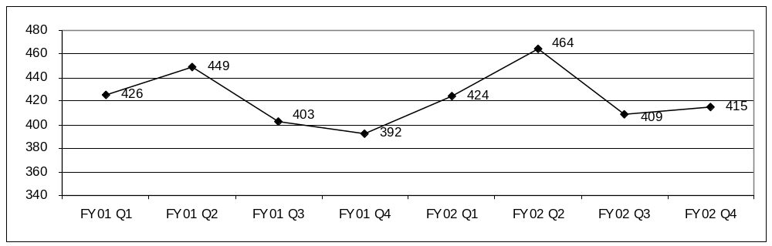

Lost Workdays Due to Occupational Injuries
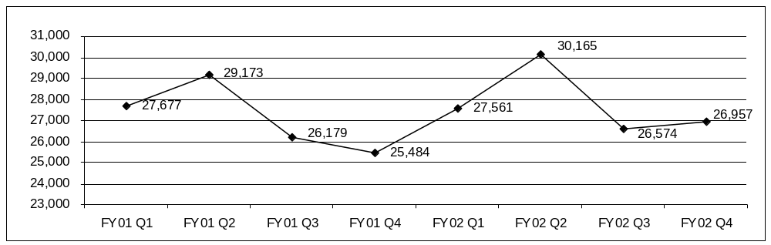
ATTACHMENT C

Accident and Injury Scorecard Report

New Lost Work Time Claims Reported per 100 Employees Per Month

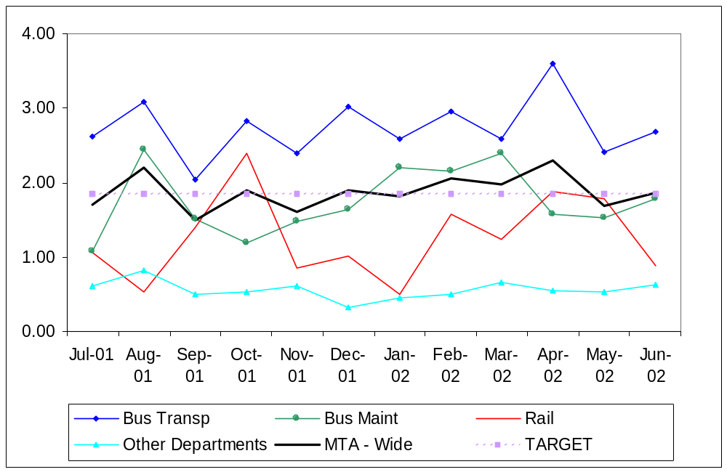
* Bus Maintenance Division data includes Facilities Maintenance and Regional Rebuild Center

 | Jul-01 | Aug-01 | Sep-01 | Oct-01 | Nov-01 | Dec-01 | Jan-02 | Feb-02 | Mar-02 | Apr-02 | May-02 | Jun-02
Bus Trans | 2.62 | 3.08 | 2.03 | 2.83 | 2.39 | 3.02 | 2.59 | 2.95 | 2.59 | 3.60 | 2.41 | 2.68
Bus Maint | 1.08 | 2.44 | 1.51 | 1.18 | 1.48 | 1.64 | 2.20 | 2.15 | 2.40 | 1.57 | 1.52 | 1.79
Rail | 1.06 | 0.53 | 1.39 | 2.39 | 0.85 | 1.02 | 0.51 | 1.58 | 1.24 | 1.88 | 1.78 | 0.89
Other Depart. | 0.61 | 0.82 | 0.50 | 0.53 | 0.61 | 0.33 | 0.45 | 0.49 | 0.66 | 0.55 | 0.53 | 0.63
MTA - Wide | 1.70 | 2.20 | 1.50 | 1.90 | 1.60 | 1.90 | 1.82 | 2.06 | 1.97 | 2.29 | 1.69 | 1.86

New Lost Time Claims for Injuries that Occurred in the Period Per 100 Employees per Month

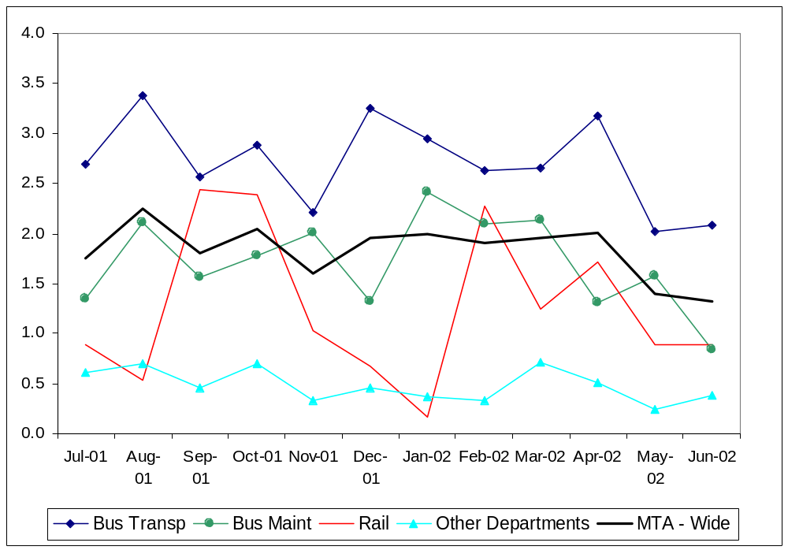

* Bus Maintenance Division data includes Facilities Maintenance and Regional Rebuild Center
Note: The thirteen months prior to the reporting month are re-examined each month to allow for reclassification
of accidents and late filing of reports.

 | Jul-01 | Aug-01 | Sep-01 | Oct-01 | Nov-01 | Dec-01 | Jan-02 | Feb-02 | Mar-02 | Apr-02 | May-02 | Jun-02
Bus Trans | 2.69 | 3.38 | 2.56 | 2.88 | 2.21 | 3.25 | 2.95 | 2.63 | 2.66 | 3.17 | 2.02 | 2.09
Bus Maint | 1.35 | 2.11 | 1.56 | 1.78 | 2.01 | 1.32 | 2.41 | 2.10 | 2.14 | 1.31 | 1.58 | 0.84
Rail | 0.88 | 0.53 | 2.44 | 2.39 | 1.03 | 0.68 | 0.17 | 2.28 | 1.24 | 1.71 | 0.89 | 0.89
Other Depart. | 0.61 | 0.70 | 0.46 | 0.70 | 0.33 | 0.45 | 0.37 | 0.33 | 0.70 | 0.50 | 0.24 | 0.38
MTA - Wide | 1.75 | 2.25 | 1.81 | 2.05 | 1.60 | 1.96 | 1.99 | 1.90 | 1.96 | 2.01 | 1.39 | 1.32

Lost Work Days Paid per 100 Employees per Month

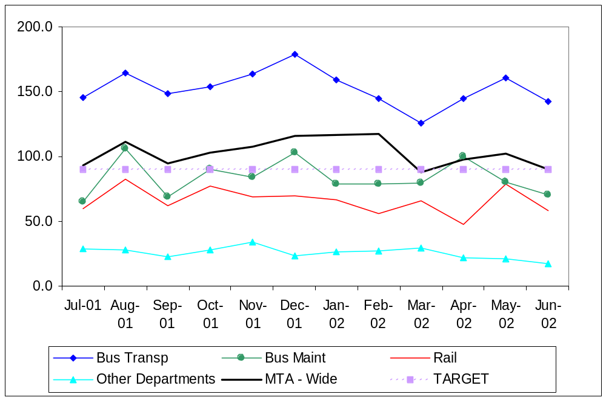

* This measure includes settlements and other payments made during the period.
It may include payment for claims not arising in the current period.
** Bus Maintenance Division data includes Facilities Maintenance and Regional Rebuild Center

 | Jul-01 | Aug-01 | Sep-01 | Oct-01 | Nov-01 | Dec-01 | Jan-02 | Feb-02 | Mar-02 | Apr-02 | May-02 | Jun-02
Bus Trans | 145.7 | 164.2 | 148.5 | 153.4 | 163.6 | 178.5 | 159.1 | 144.5 | 126.1 | 144.7 | 161.0 | 142.1
Bus Maint | 64.8 | 106.2 | 68.9 | 90.0 | 84.4 | 103.3 | 78.5 | 78.5 | 79.7 | 99.9 | 80.6 | 70.6
Rail | 60.0 | 82.8 | 62.2 | 77.4 | 69.1 | 69.7 | 67.0 | 56.1 | 65.6 | 47.6 | 78.8 | 58.2
Other Depart. | 28.7 | 27.9 | 22.6 | 28.3 | 34.0 | 23.5 | 26.6 | 27.3 | 29.6 | 22.0 | 21.2 | 17.7
MTA - Wide | 93.0 | 111.6 | 94.4 | 102.8 | 107.2 | 115.7 | 116.7 | 117.7 | 87.9 | 98.0 | 102.5 | 90.3

Bus Accidents Per 100,000 Hub Miles

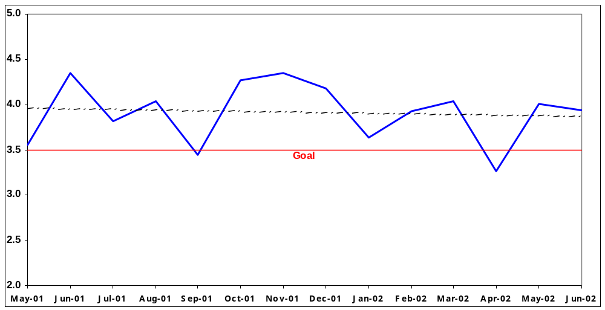
* Data represents number of bus traffic accidents (system safety performance) and not bus traffic accident claims filed.
Note: The thirteen months prior to the reporting month are re-examined each month to allow for reclassification of accidents and late filing of reports.

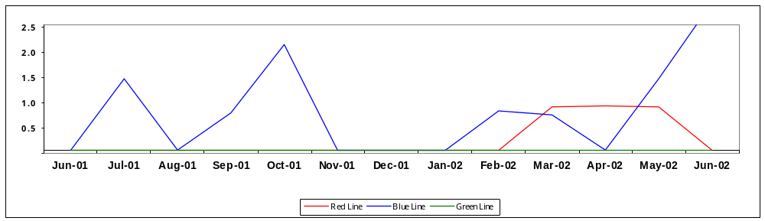Rail Accidents per 100,000 Revenue Train Miles

Note: The thirteen months prior to the reporting month are re-examined each month to allow for reclassification
of accidents and late filing of reports.

Additional training in drug/alcohol and Americans With Disabilities Act (ADA) issues will be incorporated into the training program beginning mid-August 2002.
Lost workdays regardless of injury dates. Injury may have occurred in a prior fiscal year.

