Wednesday, January 15, 2014
140115-1
In this Issue: Expo Community meetings
Email not displaying correctly? View it in your browser.
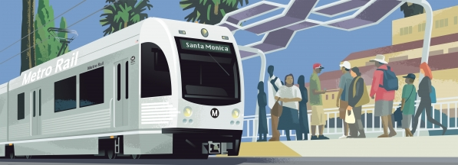

Join us for an update on Expo Phase 2!
The Exposition Construction Authority invites you to a construction update community meeting for Phase 2 of the Expo Line project. Stakeholders will receive information on upcoming construction activities and timelines.

The format will include a short presentation followed by an Open House session to facilitate dialogue and community input.
Santa Monica Construction Update
Tuesday, January 21, 2014
6:30 p.m.
Crossroads School
Community Room
1715 Olympic Boulevard
Santa Monica, CA 90404
Parking available on campus and surrounding streets
Los Angeles Construction Update
Wednesday, January 29, 2014
6:30 p.m.
Vista Del Mar Child and Family Services
Gymnasium
3200 Motor Avenue
Los Angeles, CA 90034
Parking available on campus
Planned Agenda for Community Meetings
6:30 - 7:00 p.m.: Formal Presentation
7:00 - 8:00 p.m.: Open House Session

ADA Language Accommodation: If you require an interpreter, including sign language services, or other accommodations at these community meetings, please contact Expo at least five business days prior to the meeting date at 213-243-5534.
For more information about the Expo Line project, visit our updated website at BuildExpo.org
or call 213-922-EXPO (3976).
Find us on www.Facebook.com/ExpoLine and follow us on @ExpoLine

Forward this email to a friend.
To view the meeting flier, please click here.
Our mailing address is:
Exposition Construction Authority
707 Wilshire Boulevard, 34th Floor
Los Angeles, CA 90017
Copyright (C) 2014 Exposition Construction Authority All rights reserved.

Metro.net Home | Press Room | Projects & Programs | Meeting Agendas | Riding Metro | Metro Library
Los Angeles County Metropolitan Transportation Authority
1 Gateway Plaza
Los Angeles, California 90012-2952
Phone: 213-922-6888 Fax: 213-922-7447

