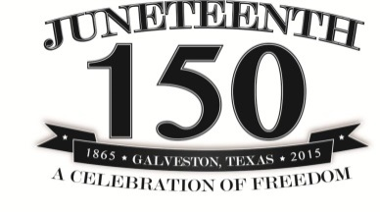
Metro AAEA
2015 Juneteenth Calendar of Events

Sunday | Monday | Tuesday | Wednesday | Thursday | Friday | Saturday
 | 1  Juneteenth Opening Ceremony  Plaza – West Patio  12:00PM – 1:00PM | 2 | 3 | 4 | 5 | 6
7 | 8 | 9  UNCF 5K Walk for Education Kickoff  Huntington Rm. & Café Lobby  12:00PM – 1:30PM | 10 | 11 | 12 | 13  Historical Trip to Allensworth, CA  Departure 7:00 A.M.  Patsaouras Plz.  Bay 3 Gateway Bldg.
14 | 15 | 16 | 17 | 18  Financial Wellness  Series - Part 2  (Estate Planning)  Plaza View Rm.  12:00PM – 1:00PM | 19  JUNETEENTH  Pioneer & Trailblazer Reception  One Santa Fe Bldg.  4:30PM – 6:30PM | 20
21 | 22 | 23 | 24 | 25 | 26 | 27
28 | 29 | 30
Checkout The Source and Metro E-Blast throughout the month for the following:
Did You Know Series – Educational Facts, Highlighting Contributions made by African Americans to the Transportation Industry
Pioneer & Trailblazer Series – Spotlighting African American Pioneers and Trailblazers: Past & Present

** Also visit the Informational & Pictorial Display of African Americans in Transportation, located in the Library, 15th Floor

