Maps, manuscripts & the masses:
successfully crowdsourcing metadata
for historic collections

Kenn Bicknell
Digital Resources Librarian
Los Angeles County Metropolitan Transportation Authority Library & Archive
bicknellk@metro.net

Abstract:
New web-based technologies are providing information professionals with tools to collect and preserve historical resources as never before. Many institutions are engaging the public in assisting them with metadata creation to improve description, increase access, and expand the body of knowledge surrounding their resources. These activities not only provide organisations with critical human resources, but build a more informed and engaged community of users. This paper reviews examples of several types of these innovative projects and what the evolution of “crowdsourced metadata” may mean for the professional role of future librarians, archivists and curators.

Introduction
“The 21st Century is a terrible time to be a control freak.” -- Alec Ross

How do we make sense of an increasingly unorganisable world? It should come as no surprise that our libraries, archives and museums (sometimes referred to collectively as galleries, libraries, archives and museums (GLAMs) or “memory organizations”) are losing the battle in keeping up with the amount of data and information of lasting historical significance generated every year. Furthermore, they obviously lack the resources to handle all of the activities related to ingestion of human knowledge: incorporation of new born-digital material into platforms built around print resources, cataloguing and indexing an increasing volume and variety of information, and building the relationships between resources that facilitate use, learning and scholarship.

In the introductory quote (Ross 2013), the former senior advisor for innovation for U.S. Secretary of State Hillary Clinton refers to his oft-stated position regarding technology “changing and challenging the hierarchical, traditional authority structures that dominated the 21st century.” The exponential growth in digital content, both born and converted, is a great thing in terms of access, but only if we can stay abreast of accessibility – and discoverability.

A “digital tsunami” has up-ended longstanding processes in most economic sectors and continues to challenge how society can adapt to increasing frequency of disruptive technological developments. Various industries, including our information professions and education systems, must embrace “citizen digital empowerment” to both prepare our users for an increasingly digital future, as well as to stay at the forefront of relevancy ourselves.

What is “crowdsourced metadata?”

One path toward digital empowerment is through crowdsourcing metadata for assets in our library, archival, and museum collections. The term “crowdsourcing” has been with us for less than a decade (Howe 2006), and is defined as “the process by which the power of the many can be leveraged to accomplish feats that were once the province of a specialized few.”

However, the concept is hardly new. Engaging the public in information-related activities dates back to the 18th century. The British Parliament established The Longitude Prize in 1714 as a means to determine longitude for sailors at sea. Accomplished scientists including Isaac Newton, Edmond Halley and Christian Huygens had been unable to come up with an answer. More than one hundred people submitted their solutions, and the prize winner was not a scientist or expert: John Harrison was a carpenter and clockmaker from rural England.

In more recent times, pharmaceutical companies have used the crowd to source drug discoveries. People from outside the medical field have contributed significantly to their findings, including computer scientists. National Geographic received 28,000 volunteers to look for Genghis Khan’s tomb in satellite imagery of Mongolia.

More recently, Wikipedia has replaced our traditional encyclopaedias of human knowledge with a body of work entirely authored and edited by the actual user. With Wikipedia (Lakhani 2013), “norms, knowledge sharing, teams, and leadership emerge to deal with what little decision making and coordination are required, but these structures are much looser than the ones found in most companies.”

After nearly a decade of forward-thinking crowdsourcing projects in our history of user engagement, we find successful application both trickling down to smaller organisations and “trickling up” to more hallowed institutions like the National Archives and Smithsonian Institution.

However, just like the Internet itself, crowdsourcing is constantly evolving and raising new questions as it solves old challenges.

Citizen archivists “connect with something a bit different than volunteerism. They are amateurs in the truest and best possible sense of the term.” (Owens 2013, p.1). He points out that “the term ‘amateur’ simply meant someone was not a professional. Charles Darwin, Gregor Mendel, and many others who made significant contributions to the sciences did so as amateurs,” in that the term ‘amateur’ means a “lover of. The primarily negative connotations we place on the term are a relatively recent development. In other eras, the term ‘amateur’ simply meant that someone was not a professional, that is, they were not paid for these particular labours of love.”

Additionally, several of the crowdsourcing areas that GLAM organizations are engaged in cross-inform each other: Human computation, the wisdom of crowds, thinking of tools and software as scaffolding, and the psychology of participant motivation.

This paper outlines some of the major categories of crowdsourcing projects and describes their benefits for libraries, archives and museums as well as individual participants. It also explores some of the risks and opportunities associated with both individual projects in addition to the potential for professional disintermediation down the road.

Crowdsourcing metadata in libraries, archives and museums yields numerous positive outcomes for both collections and users. The public receives access to richer resources, while project participants gain a degree of individual achievement and satisfaction.

Nevertheless, these are not automatic wins. Challenges abound, including: staffing considerations, coping with the volume of digital content, adequate planning, technological evolution, incorporation of metadata into traditional cataloguing and platforms, and just about every other type of project management consideration. Those considering crowdsourcing projects must also maintain awareness of user skill levels and expectations.

In order to explore these challenges and opportunities, we would be well served to review a few of the major types of crowdsourcing projects that libraries, archives and museums employ and explore examples of them.

Types and examples

Identification projects

One of the earliest (and most basic) forms of engaging “the crowd” is identification projects. Volunteers are asked to assist a library, archive, or museum in identifying what an object is, places in a photograph, or even who somebody was.

MoDiP’s “10 Most Wanted”

The United Kingdom’s Museum of Design in Plastics (MoDiP) launched its 10 Most Wanted project to request help from volunteers to add information for plastic objects in its collection (see Figure 1). Its website homepage features a digest of editorial blog posts where museum staff are discussing the project, and engages potential participants with this enticement: “Each of these objects from the Museum of Design in Plastics conceals a mystery; there’s something about it we don’t know and need your help to find out.”

Figure 1: Sample item to be identified and described at MoDIP’s “10 Most Wanted” webpage

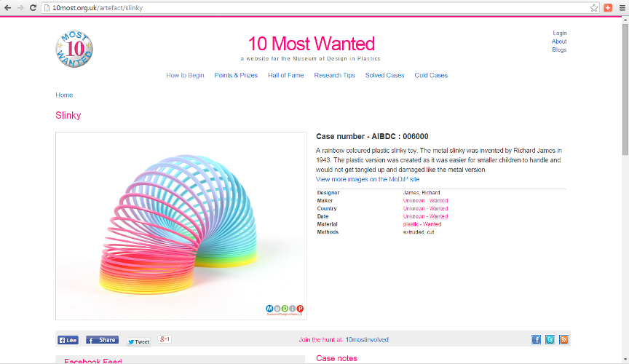

Users are invited to register to become “an agent” so the Museum can credit their contributions for posterity. They may also join the Facebook group “to see what others have done and to post what you have found.” This allows the Museum to leverage the largest social network on the planet as a platform for building a community of users interacting with each other as well as items in their collection.
The website features an extensive structure of levels for earning points and prices. Solvers work their way up from Special Mention to Silver Star (promotion from “field agent” to “special agent”), which merits invitation to the “10 Most Wanted Get-Together to meet the objects, other agents and HQ staff to share and reflect on your experiences of the project. “Cake included.”

At Gold Star, the user is promoted from Special Agent to Chief Agent, and so on. Perhaps most importantly, the Museum offers the user what it calls “Lasting fame,” with their special mentions preserved indefinitely in case notes and become part of the permanent record for the MoDiP collection, so they become as immortal as the artefacts themselves.

Transcription projects

In addition to identification projects, transcription projects large and small are helping libraries, archives and museums in tremendous ways. While some transcription efforts need volunteers to turn handwritten documents into machine-readable form, other innovative programs are capturing the imagination of potential participants in becoming citizen scientists and amateur historians.

Old Weather

Some crowdsourced projects have evolved into the next-generation concept of multi-institutional collaboration. At Old Weather, scientists from nearly a dozen institutions are working together, using the Zooniverse crowdsourcing platform, in asking the public to help them gather information about historical weather variability to improve weather and climate predictions for the future.

Figure 3: Old Weather explains “Why Scientists Need You”

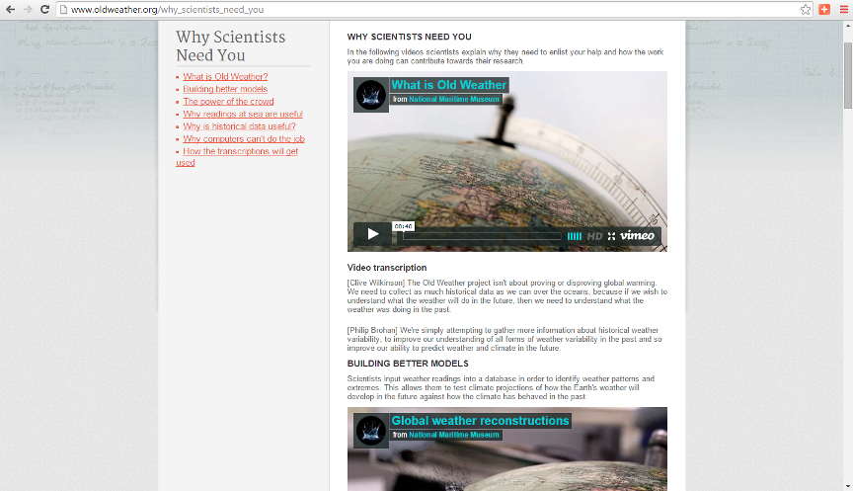

The project managers place the importance of crowdsourcing front and centre, proclaiming that “the more people that take part in Old Weather, the more accurate the extracted data will be. Each logbook will be looked at by more than one person, allowing mistakes and errors to be filtered out…Logbooks are difficult for a computer to analyse accurately. Reading handwritten text is a skill that people and not computers excel in. Handwriting is often confused and misinterpreted by them, which can lead to errors in the data. Humans are also better at identifying important information.” Figure 3 shows the project’s “Why Scientists Need You” webpage, which contains extensive information regarding the benefits of citizen science activity, “why computers can’t do the job,” the uses of historical data, video embeds and other information inviting participation in a truly meaningful and useful activity.

Mapping projects

Some of the most exciting crowdsourcing endeavours involve cartographic resources. Maps offer crowdsourcing participants a spatial environment in which to work, as well as creative collaborations across collections.

New York Public Library Digital Labs

The New York Public Library has developed and successfully deployed several engaging crowdsourcing projects. Its Digital Lab’s Map Warper site offers participants the opportunity to “align (or rectify) historical maps to the digital maps of today.” This project provides the user with a chance to interact with both historical resources and cutting-edge technology as they immerse themselves in historical New York. The Digital Lab’s Building Inspector project asks citizen surveyors to correct machine-generated building footprints on old maps. The user is asked to optimise computer-sourced building outlines one at a time, allowing them to “kill time and make history” in development of the Lab’s groundbreaking Space/Time Directory.

Map Warper and Building Inspector are part of a foundational suite of crowdsourced projects that will lay the groundwork for something far grander. This may very well be the beginning of another type of next-generation of crowdsourced metadata projects for libraries, archives and museums. The Space/Time Directory, which has already secured funding from the Knight Foundation, promises to a number of outcomes from pulling together individual projects, where the total value is greater than the sum of its parts, as explained on its webpage:

- “A searchable atlas of New York City’s past stitched together from the pages of old maps (Think Google Maps with a time slider)
- A historical location directory and geocoder that helps you find your place in time (Think historical FourSquare or Yelp)
- A discovery tool linking cultural heritage material (photographs, newspapers, business directories, literary references, census data and much more) in historical and geographic context. (City as catalog)
- A set of APIs and data sets that digital humanists, journalists, and developers can use to create new views of the past (Vintage big data)
- A model and code base for other cities and libraries to map their histories. (Time machine in a box: Build a Space/Time Directory for your city!,” Figure 6)
Figure 6: New York Public Library’s “Space/Time Directory” website, future home of aggregated crowdsourced projects such as Map Warper, Building Inspector and other interactive spatial, historical assets
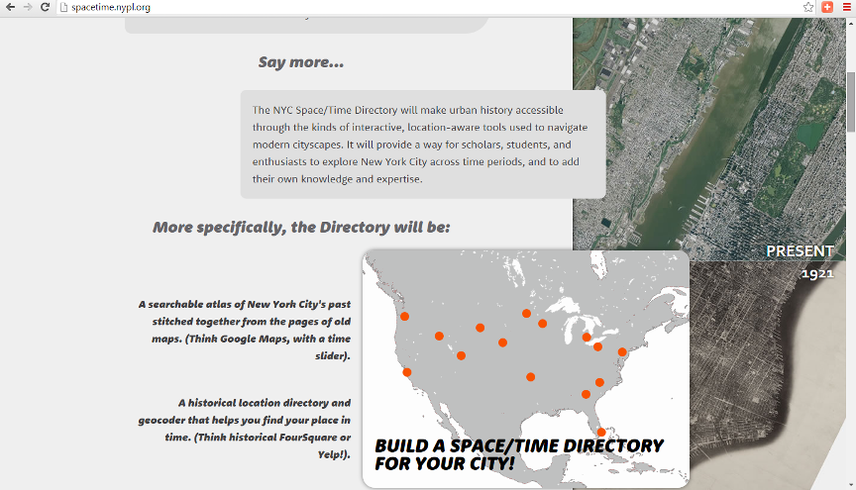
Perhaps this last point is the most important. The Space/Time Directory is a multi-faceted model for other cities and regions wherein each successive emulator may choose components that suit its own community and to develop larger scale concepts.

New York Public Library’s Digital Lab staff have also begun building an infrastructure for an object-centred digital library with extensive public participation, metadata and curation. One project within this new area includes the Stereogranimator, “a tool for the public to transform historical stereographs from the New York Public Library and other participating organizations into 3D web formats” – a 21st century repository of public creations out of 19th century treasures.

As this suite of projects grows, participation grows too, both in terms of sheer numbers and in terms of robust cross-over between projects. For example, Digital Labs’ “Ensemble” project has generated more than 20,000 transcriptions from New York playbills with virtually no project promotion of its own. Digital Labs’ staff is looking forward to development of a social architecture as a foundation for participants to share knowledge and interact with one another (Vershow, 2015).

User-generated content projects

Another type of user-generated metadata comes from projects revolving around user-generated content itself. Today, cultural heritage organisations are moving beyond user-contributed metadata towards comprehensive projects that rely on the public beginning with creation and ending with consumption.

For example, libraries, archives and museums have embraced oral history projects that increasingly rely on citizen historians to identify and record stories of neighbourhoods, historical periods or individuals with compelling experiences and observations.

New York Public Library’s program is centred on neighbourhoods, building community around the city’s diversity. The public is invited to participate in not only creating the oral histories, but also in transcribing the recordings. Interviews are fed through a voice-to-text transcription generator, rendering a readable version of the audio file. Citizen historians can work with the audio while reading along, pausing the recording to correct the print version. (Vershow, 2015).

September 11 Digital Archive

The September 11 Digital Archive collects, preserves, and provides access to the history of the September 11th, 2001 terrorist attacks in New York City, Washington, D.C. and Pennsylvania. “The Archive is publicly curated and also using these events as a way of assessing how history is being recorded and preserved in the twenty-first century and as an opportunity to develop free software tools to help historians to do a better job of collecting, preserving, and writing history in the new century.” A straightforward webpage with a simple interface invites the public to share their own stories of what happened to them on 9/11 and how it has changed their lives (Figure 7).

Figure 7: September 11 Digital Archive electronic contribution form

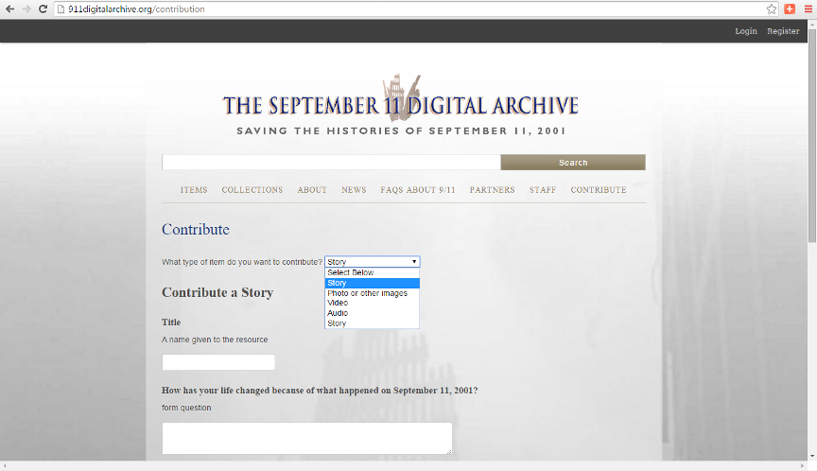

Additional opportunities and benefits

A frequently mentioned attribute of crowdsourcing projects in GLAMs is the “opening up” or democratization of our shared history’s documentation. Mary Flanagan (2015) writes that we own our own histories and we should be able to embellish and enrich what we know about our own history. And, “with the scale of our work, we cannot do it ourselves. Why not democratize archives through community participation?”

One can see that in just the past decade or so, libraries, archives and museums have embraced crowdsourcing as a beneficial activity. Several of these benefits include (Holley 2010):
- Achieving goals the library would never have the time, financial or staff resource to achieve on its own
- Achieving goals in a much faster time frame than the library may be able to achieve if it worked on its own
- Building new virtual communities and user groups
- Actively involving and engaging the community with the library and its other users and collections
- Utilising the knowledge, expertise and interest of the community
- Improving the quality of data/resource (e.g. by text, or catalogue corrections), resulting in more accurate searching
- Adding value to data (e.g. by addition of comments, tags, ratings, reviews)
- Making data discoverable in different ways for a more diverse audience (e.g. by tagging)
- Gaining first-hand insight on user desires and the answers to difficult questions by asking and then listening to the crowd
- Demonstrating the value and relevance of the library in the community by the high level of public involvement
- Strengthening and building trust and loyalty of the users to the library. Users do not feel taken advantage of because libraries are non-profit making.
- Encouraging a sense of public ownership and responsibility towards cultural heritage collections, through user’s contributions and collaborations

Holley goes on to suggest that we should assume volunteers will do it right rather than get it wrong. She explains that “Experience shows that the greater the level of freedom and trust you give to volunteers the more they reward you with hard work, loyalty and accuracy. Rather than assuming everything will go wrong and spending valuable time putting systems in place to stop vandalism, assume volunteers will do their best and monitor and help each other. Give them as much freedom as you are able.”

Another opportunity to be explored is partnering with educational institutions. Participants may be recruited if they are offered academic credit or other incentives. The Huntington Digital Library has developed a Zooniverse-based crowdsourcing site to enlist the public in decoding and deciphering nearly 16,000 Civil War telegraph messages. One goal of the project is to engage a broader audience through education modules integrated into teacher workshops reaching more than 1,000 instructors of at-risk students.

As projects mature and others take advantage of open-source platforms such as Zooniverse, we may see more robust participation as users take advantage of commenting capabilities, asking questions, passing judgments and working together on other tasks. Ben Vershow (2015) has noted that Zooniverse is developing an “even more robust technical platform where you can spin out projects without any technical assistance, and other platforms have emerged.”

Crowdsourcing may also become an in-person activity. Wikipedia edit-a-thons take place in numerous locations every year. This format could be relatively easily replicated for crowdsourcing GLAM metadata. Along with these opportunities comes a rising challenge and opportunity – how to deal with the flood of additional data generated. Here, data visualization for an increasingly visual world may pique participants’ interests and play a future role in crowdsourced metadata and interpretation of digitized cultural and historic resources. McGhee (2015), writing on citizen science, notes that “big data and data visualization [give] us the chance to make sense of data points.”

Challenges and risks

However, all of these benefits come with some conditions. It has been pointed out (Leon 2014) that many crowdsourcing projects start off as micro, one-off initiatives, with no environmental scan or survey of the world as with grant proposals.

Project design must consider incorporating tasks that are easy enough for the public to participate in but challenging and interesting enough so that their participation is sustained over time. An investment up front addressing this challenge could save a lot of time and energy later in the project lifecycle.

As GLAMs experiment with crowdsourcing initiatives, some are not designed for long-term support or maintenance. They may not be around forever, and they may not have secured long-term funding. Even if a project is designed as an experiment, questions should be asked about what is done with crowdsourced metadata once the public participation has ended. Does it remain on a webpage to be accessible in perpetuity? Is it integrated with expert-derived metadata forever?

In the race to collect resources of lasting historic significance contributed by the public in a timely fashion, GLAM professionals are challenged with resource allocation in the planning for, integration of and long-term maintenance related to metadata.

For example, a young man named Freddie Gray died on 19 April 2015 following his arrest by Baltimore, Maryland police. This led to citywide protests and a series of local and national investigations. Fifteen days after his death, the Maryland Historical Society issued a public call for images from professional and amateur photographers to document the protests, unrest and clean-up efforts in Baltimore following the “Freddie Gray riots.” The Society also initiated its appeal to the public to share their oral histories and objects related to the 2015 Baltimore events.

A press release from the Society President states that “We have the resources to interpret these events as well as what has happened in the past.” However, it is an enormous challenge for institutions of all kinds to balance ongoing collection of resources against systematic description of those resources and existing projects.

And how do we determine the extent to which diverse participation is critical in projects both large and small – and measure that even if we can make such a determination, especially in the rush to gather time-sensitive resources? We can look to Wikipedia for some considerations. While some articles are robust, others are not. Even where one finds relatively “complete” information on a particular topic, the user has no insights into the background (or possible bias) of the article editors. Pappas (2014) has noted that a 2011 Wikimedia Foundation survey found that females accounted for only 9% of all active editors.

Institutions considering projects may want to ask how do GLAM crowdsourcing projects identify, reach and include new communities that are not currently engaged with their institution or collections? How meaningful is it to increase representation in the quest for additional metadata and the most accurate information?

MoDiP shared its “lessons learned” in a post-mortem report (Lambert, Blume & Winter 2015) nine months after the launch of its 10 Most Wanted project. Over 300 people registered with the website, 43 people joined the project’s Facebook group, and 27 individuals contributed posts. Overall, the Museum logged 548 interactions, including 76 “wanted” facts found and 76 images contributed.

Fifty percent of museum professionals contact by MoDip expressed that they were not entirely comfortable with crowdsourcing the documentation of collection artefacts, and only fifty-seven percent were comfortable with how 10 Most Wanted coverted user-generated information into formal documentation. However, seventy-five percent thought the approach was useful for engaging people.

MoDiP reports that the most important lessons were having a separate website to facilitate project branding, and reuse for other purposes. It placed a high value on non-exclusive license to use submitted content respecting participants’ copyright without restricting future use and a “terms and conditions” element in the sign-up procedures. Finally, the report mentions facilitation by the museum as critical for nurturing the volunteer community in sustaining participation and turning contributions into evidence trails for valuable metadata. It should also be noted that annual visits to MoDiP rose from 57,590 in 2012/13 to 75,626 in 2013/14. The implication in the report is that project awareness stimulated an increase in in-person attendance by more than thirty percent in one year.

Another challenge to crowdsourcing initiatives may be future pushback from the other crowd: in this case, the potentially disintermediated professional librarians, archivists and museum workers. For example, in the private sector, the “No!Spec” campaign seeks to “educate those in the design professions, as well as clients who use their services, about why spec work harms the design profession as well as the outcome of design projects.”

Others (Weinstein 2013) have opined that perhaps even more ominous is the mounting lawsuits brought against crowdsourced labor platforms like Crowdflower and Amazon Mechanical Turk. The tasks performed are compensated at far below the legal minimum wage for work in the United States, and class-action lawsuits could derail entire crowdsourced platforms.

Worse yet, some institutions may fear it is not worth the risk to move forward with innovative public participation platforms if they expose themselves to even the risk of looking like they are taking advantage of their users or enthusiasts (Kessler 2015). The “Gig Economy” is threatened overall because of litigious pushback, arguing that it may be time to strike a new definition of the term “employee.”

While these private sector examples are hardly the same as inviting public participation in cultural heritage projects, they may be the beginning of a trend that could influence the future of how crowdsourcing and unpaid contributions are viewed overall.

Organising the crowd of crowds

The Crowd Consortium for Libraries & Archives (CCLA) in the United States organised in 2014 to support research and deployment of crowdsourcing for cultural heritage institutions. The aim of CCLA is to bring together libraries, archives, and museums to effectively use crowdsourcing techniques and to enhance the public experience of libraries, archives, and museums. The Consortium is a forum that enables interested stakeholders to join a national conversation about the most pressing needs and challenges regarding the development and deployment of crowdsourcing technologies in the cultural heritage domain.

This nascent collective brought together over 60 stakeholders from the humanities, sciences, and cultural heritage domains to share their experiences managing digital projects that invite contributions from virtual volunteers. As a capstone to a series of Institute for Museum and Library Services-funded workshops, CCLA has established a forum that enables a national conversation about the most pressing needs and challenges regarding crowdsourcing in the cultural heritage domain. The event also serves as part of the U.S. National Endowment for the Humanities agency-wide initiative, “The Common Good: The Humanities in the Public Square,” which seeks to demonstrate and enhance the role and significance of the humanities and humanities scholarship in public life.

The United States National Archive is moving toward eventually having a catalog where all fields of archival data can be written to by the public. Archivist of the United States David S. Ferriero (2013, p.3) explains, “We will launch a new Online Public Access (OPA) catalog to improve search and scalability as well as mobile optimise the site, create a public API, and introduce crowdsourcing fields for citizen archivists to contribute to the online catalog…NARA will also sponsor two fellows during the third round of the Presidential Innovation Fellows program in 2014. The fellows will lead open development of crowdsourcing tools that will help unlock data and information from records formats and allow the public to easily contribute to the records.”

Our memory organisations are finding innovative ways to stay abreast of the exponential growth in digital content. The challenge is to make adoption of these methods as easy and possible to scale for many types of institutions. Information professionals should welcome the challenge of adapting to sea-change trends. After all, libraries originated the sharing economy and “the Library” is democracy’s original maker-space.

But how do librarians, archivists and museum professionals interact with Google and others who are seeking to digitise the world’s print collections? Many academic journals are already digital-only and are available from a shrinking number of publishers. Does an open access movement from end users push back against this centralisation of the information provision?

In essence, we are all librarians now and we are connected directly to the entire information universe, which was once the preserve of the privileged few (Nicholas 2012).

More books and periodicals are being published today than ever before. It is difficult to imagine wholesale disintermediation of librarians and archivists unless libraries disappear altogether as well. Somebody needs to aggregate the work of the aggregators – directing people to the best source for the information they want, no matter where it is. Somebody needs to curate the work of the curators, and somebody needs to handle reference when the Google search engine – or at least its user – fails. (Coffman 2013)

However, unintentionally, our information professionals “may be forfeiting the opportunities to offer professional knowledge and skill in an attempt to provide equitable service to everyone.” (Agee 2003, p. 478) Any disintermediation of librarians and others could lead to a greater re-intermediation with a central, critical role in a totally digital future. Owens (2013) argues that “this is one of the places where libraries, archives, and museums have the most to offer. As stewards of cultural memory, our institutions have a strong sense of purpose and their explicit mission to serve the public good. This notion of motivation prompts further key questions for projects: Whose sense of purpose does this project connect to? What identities are involved? What kinds of people does this project matter to? And how can we connect with and invite the participation of those people? ... We are in a position to let users of these collections leave a mark on the collections. Instead of browsing through a collection they literally become authors of the historical record.” Lankes (2011, p.65) takes a similar position, arguing that in the future, “the mission of librarians is to improve society by facilitating knowledge creation in their communities.”

Conclusion: Lessons Learned & Ways Forward

Public participation in the creation of metadata for GLAMs is a relatively new activity. It is understandable that uniform best practices have not yet emerged. Projects are unique to each collection, institution and participant base. Some principles have been shared in professional literature, but we definitely cannot develop a one-size-fits-all approach in creating a best practices framework.

One set of best practices considerations for quality control comes from Owens & Blake (2014):
- Use publicly-contributed metadata as an additional search feature, but do not prominently feature it
- Empower users to moderate, review and flag metadata
- Run the same task multiple times to elicit multiple responses to triangulate answers
- Compare a subset of publicly-contributed metadata to expert responses to evaluate participant performance
- Use a blacklist or whitelist to restrict and structure the nature of contributions
- Maintain provenance of data sources
- Embrace the perspectival nature of crowd-sourced data documenting how people responded to requests for help

The United States Environmental Protection Agency now coordinates the Federal Community of Practice on Crowdsourcing and citizen science to share lessons learned and develop best practices for designing, implementing, and evaluating crowdsourcing and citizen science initiatives.

Mia Ridge (2013), writing on crowdsourcing in GLAMs, recommends two key steps in launching a crowdsourced metadata project: “Try to design small inherently satisfying microtasks” and “show the value of the participants’ action by making their contribution immediately available on your site.”

However, the JISC Digital Media Guide to crowdsourcing (2015) recommendation is somewhat contrary to Ridge’s microtasks recommendation, listing “Have a big target” as a desirable feature. The guide notes “most successful crowdsourcing projects have targets that would be impossible to reach with just a core team of professional staff. Indeed, evidence would suggest that the bigger the task or problem faced, the more likely people are to get involved.” It goes on to note that Old Weather estimated it could take one person up to 28 years to accurately transcribe one Captain’s logbook from one voyage while public participants could do it in six months.

Perhaps these two concepts are mutually exclusive. One can imagine that a GLAM project can enlist the public in describing or transcribing one facet of its resources for a large number of items in its collection. If institutions band together, they could also embrace both of these concepts. The Trove project at the National Library of Australia has posted some impressive statistics on its website, breaking down the numbers for each project into “current work counts by contributor.” Numerous institutions and projects of all sizes are part of over 450 million items as of 9 November 2015.

Regardless of what the future holds for amateurs, experts, citizen metadata creators or information professionals, we are all witness to wider adoption of open-source platforms for institutions of all types to get in on the act and strive for vastly larger accomplishments.

Flanagan (2015) writes that “As we work together, we are working towards more interoperability, joint services, more tools, evaluation techniques, federating our data in ways that will scale and reach more people. We can share what we have learned, build on each other’s knowledge, and there are lots of different groups coming at crowdsourcing. We haven’t yet crystallized around one set of tools and best practices, and it is time we at least move forward the conversation on best practices…as we focus on questions around how researchers and institutions might best leverage crowdsourcing strategies for increasing public engagement, integrating data into existing collections, and improving knowledge production in a variety of domains.”

As Eveleigh (Ridge ed. 2014, p. 226) explains, “Crowdsourcing in cultural heritage is ultimately all about making connections – in its different guises these may be connections between traces of the past or between people in the present. Perhaps its enduring legacy will be in fostering the participants’ perspective of the digitised cultural heritage realm, encouraging professionals in these fields too to transcend their own view of the world – to focus then not inwardly on narrowly defined disciplinary goals, but to look outwards, embracing complexity and uncertainty, but also opportunity.”

References

Agee, J 2003, “Stone buildings, cyberspace, and the library user,” New Library World, vol. 104, no. 1194/1195, p. 474-480.

Coffman, S 2013, “So now what?: The future for librarians” Online Searcher, vol. 37, no. 1. [Online]. Available: <http://www.infotoday.com/OnlineSearcher/Articles/Features/So-Now-What-The-Future-for-Librarians-86856.shtml>

Crowd Consortium, Crowd Consortium, viewed 25 July 2015, <http://www.crowdconsortium.org>

Eveleigh, A 2014, “Crowding out the archivist? Locating crowdsourcing within the broader landscape of participatory archives” in Crowdsourcing our cultural heritage, Ashgate, Farnham

Ferriero, D 2013, Open government plan: National Archives and Records Administration, viewed 23 July 2015, [Online]. Available: <http://www.archives.gov/open/open-government-plan-3.0.docx>

Flanagan, M 2015, National digital platform for libraries, archives and museums, viewed 8 November 2015, [Online]. Available: https://www.imls.gov/sites/default/files/publications/documents/2015imlsfocusndpreport.pdf

Holley, R 2010, “Crowdsourcing: how and why should libraries do it?” D-Lib Magazine, vol. 16, no. 3-4. [Online]. Available: <http://www.dlib.org/dlib/march10/holley/03holley.html>

Howe, J 2006, “The rise of crowdsourcing,” Wired Magazine. [Online]. Available:
<http://www.wired.com/wired/archive/14.06/crowds.html>

Huntington Digital Library (2015), “Thomas T. Eckert Papers,” viewed 1 November 2015, <http://hdl.huntington.org/cdm/landingpage/collection/p16003coll11>

JISC, 2015, “Guide: crowdsourcing,” viewed 6 November 2015, <http://www.jiscdigitalmedia.ac.uk/guide/Crowdsourcing>

Kessler, S 2015, “The gig economy won’t last because it’s being sued to death,” Fast Company. [Online]. Available: <http://www.fastcompany.com/3042248/the-gig-economy-wont-last-because-its-being-sued-to-death>

Lakhani, L 2013 “Using the crowd as an innovation partner,” Harvard Business Review. [Online]. Available: <https://hbr.org/2013/04/using-the-crowd-as-an-innovation-partner/>

Lambert, S, Blume, P & Winter, M 2015, Museum of Design in Plastics: crowdsourcing game: research and development report, Digital R&D Fund for the Arts, London

Lankes, D 2011, Atlas of new librarianship, MIT Press, Cambridge.

Leon, S 2014, “Notes from the inaugural working meeting of the Crowdsourcing Consortium for Libraries & Archives (CCLA)”. [Online]. Available: <http://crowdconsortium.org/notes-proceedings/cclaboston/>

Maryland Historical Society, Maryland Historical Society issues public call for photographs, viewed 7 November 2015, <http://www.baltimoreuprising2015.org/history>

McGhee, G 2015 “People-powered data visualization,” National Geographic. [Online]. Available: http://news.nationalgeographic.com/2015/08/150825-data-points-citizen-science/

Museum of Design in Plastics, 10 most wanted, viewed 19 August 2015, <http://www.10most.org.uk/>

National Library of Australia, Trove: current work counts by zone, viewed 30 October 2015, <http://trove.nla.gov.au/system/counts>

New York Public Library, NYC Space/Time Directory, viewed 6 August 2015, <http://spacetime.nypl.org>

New York Public Library, NYPL map warper, viewed 6 August 2015, <http://maps.nypl.org/warper/>

New York Public Library, Stereogranimator, viewed 6 August 2015, <http://stereo.nypl.org>

Nicholas, D 2012, “Disintermediated, decoupled and down,” CILIPUPDATE. [Online]. Available: <http://ciber-research.eu/download/20120501-CILIP_Update_March_2012_pp29-31.pdf>

No!Spec, About, viewed 10 August 2015, <http://www.nospec.com/about>

Old Weather: our weather’s past, the climate’s future, Why scientists need you, viewed 6 August 2015, <http://www.oldweather.org>

Owens, T 2013 “Digital Cultural Heritage and the Crowd” The Museum Journal, vol. 56, no. 1.

Owens, T & Blake, T (2014) Evaluating crowd contributions: quality assurance & control for user contributed items and metadata, in Notes from the inaugural working meeting of the Crowdsourcing Consortium for Libraries & Archives (CCLA), viewed 4 November 2015, < http://www.crowdconsortium.org/notes-proceedings/cclaboston/>

Pappas, S (2014) “Wikipedia’s gender problem gets a closer look” Live Science, viewed 3 November 2015, http://www.livescience.com/48985-wikipedia-editing-gender-gap.html

Ridge, M (2013) “Tips for digital participation, engagement and crowdsourcing in museums”, viewed 5 November 2015, <http://www.londonmuseumsgroup.org/2013/08/15/digital-participation-engagement-and-crowdsourcing-in-museums/>

Ridge, M (ed.) 2014 Crowdsourcing our cultural heritage, Ashgate, Farnham

Ross, E (2013) “Exit Interview: Alec Ross on Internet Freedom, Innovation and Digital Diplomacy,” Huffington Post, March 12, 2013. [Online]. Available: <http://www.huffingtonpost.com/alexander-howard/exit-interview-alec-ross-_b_2860211.html>

The September 11 Digital Archive, Saving the histories of September 11, 2001, viewed 30 July 2015, <http://911digitalarchive.org/about>

Shaping SF, Shaping San Francisco: excavating the city’s lost history, viewed 1 August 2015, <http://www.shapingsf.org/about/index.html>

United States Environmental Protection Agency, Federal Community of Practice on Crowdsourcing and Citizen Science, viewed 2 November 2015, <http://www2.epa.gov/innovation/federal-community-practice-crowdsourcing-and-citizen-science>

University of Oxford, Ancient Lives, viewed 1 August 2015, <http://www.ancientlives.org>

Vershow, B (2015) Interviewed by Kenn Bicknell at New York Public Library, 6 August 2015.

Weinstein, S (2013), “CrowdFlower lawsuit could change crowd labor industry forever” Tiny Work, viewed 25 July 2015, <https://tinywork.wordpress.com/2013/07/29/crowdflower/>

