 |  | Daily Brief
Friday January 20, 2006  20060120-0 |  | CEO Roger Snoble
In this issue:
- Legislature Gears Up for Hearings on Infrastructure Bond Proposals
- State Legislators Appointed to Transportation Infrastructure Bond Conference Committee
- Call For Major Investment In Transportation
- Metro Gold Line Limited Stop Service
- Eastside Review Advisory Committee Meeting
- Metro On-Line Store/Chinatown Celebration
- Upcoming CEO Meetings & Events

Legislature Gears Up for Hearings on Infrastructure Bond Proposals

The Assembly and Senate have scheduled a series of informational hearings in Sacramento to begin the process of sifting through the various infrastructure bond proposals. On Tuesday, January 24 at 1:30 pm, the Senate Transportation Committee will convene a hearing entitled "The Governor's Strategic Growth Plan: Overview and Reactions". In addition, the Assembly Transportation Committee will meet on Monday, January 30 to review the Governor's plan as well as bond proposals introduced by Speaker Nunez and Senator Perata. Metro's legislative advocacy team will attend the hearings and keep you apprised of any new developments.

State Legislators Appointed to Transportation Infrastructure Bond Conference Committee

State Senator Kevin Murray (D-Los Angeles) has been named chairman of a six member conference committee that will review the impacts of major infrastructure bond proposals authored by Senate President Don Perata, Assembly Speaker Fabian Nunez and Governor Arnold Schwarzenegger. Members of the joint conference committee are Senators Wesley Chesbro, Dennis Hollingsworth, and Assemblymembers Carol Liu, John Laird and Rick Keene. The conference committee is expected to begin hearings on the bond proposals in early February. The deadline for Legislative approval of bonds to be placed on the June 8 primary election ballot is March 15.

Call For Major Investment In Transportation

Numerous local and national news media attended today’s news conference at Union Station held by Gov. Schwarzenegger and Mayor Villaraigosa to call for major investment in transportation. Speaking at the news conference, the Governor and the Mayor explained how investing wisely in California’s transportation infrastructure will decrease commute times, speed freight delivery, improve air quality and create jobs, as the state prepares for its projected growth. Mayor Villaraigosa commended Governor Schwarzenegger for recognizing the considerable transportation challenges facing California and agreed that it is critical for our state’s future that we make substantial investments in our transportation infrastructure. News stories are expected throughout the day and evening.

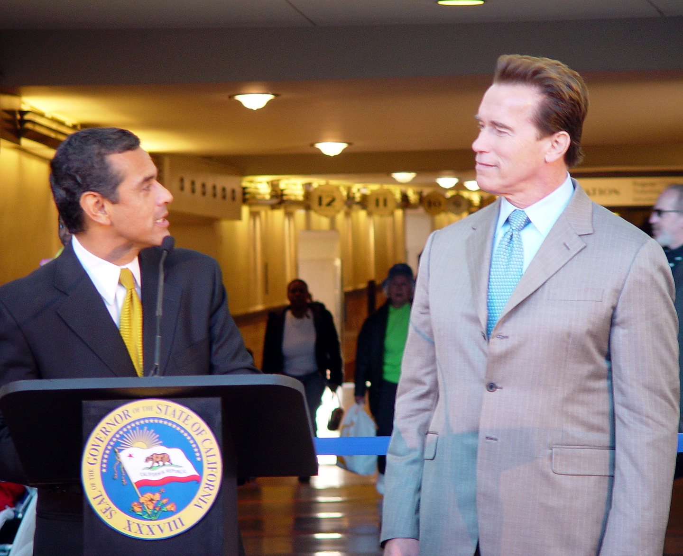

Metro Gold Line Limited Stop Service

KFI radio interviewed Media Relations staff today on Metro’s plans to introduce new limited stop service on the Metro Gold Line beginning Monday, Feb. 13. KCBS-TV ran a short story on the new service during their morning newscasts and City News Service also ran a story highlighting the new service.

Eastside Review Advisory Committee Meeting

Last night January 19th, Metro project staff presented construction and community relations updates to the Metro Gold Line Eastside Extension Review Advisory Committee (RAC). Among the items presented were the video of the December 2005 Tunnel Boring Machine media event, Ramona Opportunity High School/Indiana Station Relocation status, and the invitation to the February 23rd RAC Ad-Hoc Sub-Committee. This Sub-Committee is being formed to provide community guidance and direction on the re-interment plans and memorial for the human remains that were discovered last year during Metro excavation at the Los Angeles County Crematorium site.

Metro On-Line Store and Chinatown Celebration

Media Relations issued a news release today promoting the Metro Store and the fact that transit-oriented merchandise is available as souvenir items. Media Relations also issued a news release encouraging patrons to use the Metro system to visit this year’s celebrations in Chinatown for the Year of the Dog celebration of Chinese New Year.

Upcoming CEO Meetings & Events

Next week, I will be meeting separately with: Director Fleming, Supervisor Antonovich, Director Pam O'Connor, Supervisor Yvonne Burke, and Tony Kouneski of APTA. I will also be attending the Los Angeles Area Chamber of Commerce 117th Annual Inaugural Dinner.

Metro.net Home | Press Room | Projects & Programs | Meeting Agendas | Riding Metro | Metro Library

Los Angeles County Metropolitan Transportation Authority
1 Gateway Plaza
Los Angeles, California 90012-2952
Phone: 213-922-6888
Fax: 213-922-7447

